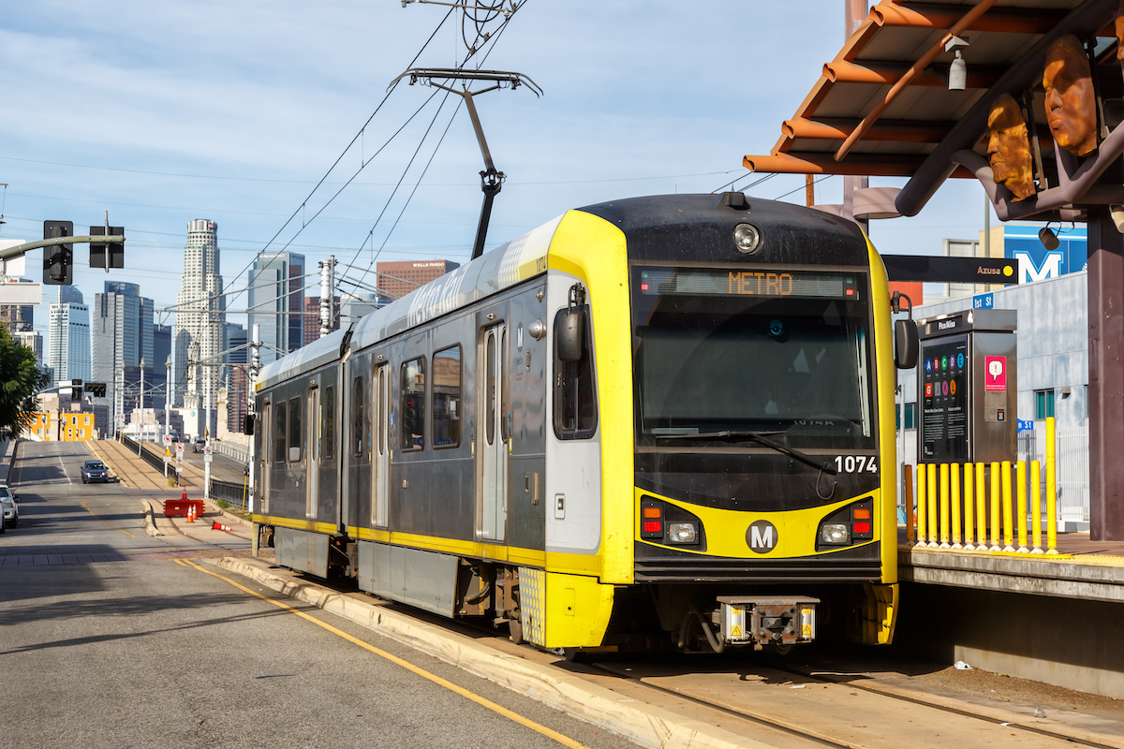Pico Boulevard Safety and Connectivity Project

Social Climate Analysis

Christina Stacy Gabe Samuels Teddy Maginn

Urban Institute Urban Institute Urban Institute

Name Name Name

Organization Organization Organization

Prior Contributors: Helen Campbell, Kyle Hickey, Louie Leiva, Genevieve Arce, Andrew Westall, Danielle Mero, Hakeem Parke-Davis, Jungmin Lee

April 2025

Contents

Introduction 4

Project Overview 7

Section One: Project Area and Community Background 12

Demographic Profile 12

Language Access and Cultural Considerations 18

Other Accessibility Considerations 22

Housing and displacement risk 26

Transportation and commuting 29

Land use 34

Section Two: Field Observations 38

Major Stakeholders and Outreach Considerations 38

Existing Infrastructure and Use Patterns 38

Segment 1: Bonnie Brae St to Magnolia Ave 39

Segment 2: Magnolia Ave to Vermont Ave 41

Segment 3: Vermont Ave to Catalina St 44

Summary 46

Observations from Project and Engagement Team 47

Means of Transportation and Pedestrian Safety 47

Informing Residents of Projects 47

Suggestions From Residents to Improve Pedestrian Safety 48

Storytelling and Participatory Planning 48

Section 3: Key Recommendations 49

Outreach strategy recommendations based on demographics 49

Language Access 49

Digital Access 50

Disability Status 51

Age 52

Race/Ethnicity 54

Family structure 55

Other considerations 55

Recommended Project Partners & Ambassadors 57

Business Engagement Recommendations 57

Scope and Timeline Considerations (if applicable) 57

Appendix A. Public Comments 58

References 59

Notes 60

# Introduction

Research shows that engagement practices and public involvement related to transportation and land use have historically prioritized the perspectives of people with higher incomes, white people, and homeowners (Einstein, Glick, and Palmer 2019). However, targeted outreach strategies can help to increase equity in community engagement, such as hosting events in locations that underrepresented communities regularly visit such as recreation centers, schools, or service locations, providing many options for discussion and input, and paying people for their time and providing other supports – such as childcare, language interpretation, and meals – at meetings (Stacy et al. 2022).

To support inclusive engagement efforts, our team conducted a social climate analysis for the Pico Boulevard Safety and Connectivity Project using an equity-centered approach. This analysis aimed to deepen understanding of the community’s demographic makeup, lived experiences, and priorities. Our goal was to help shape a culturally responsive and inclusive engagement strategy that centers the voices and values of local residents—especially those who have been historically marginalized in transportation and land use decision-making.

This Social Climate Analysis includes three core components:

* **Demographic and Spatial Data Analysis** – We analyzed a range of indicators including poverty, transportation access, language access, disability status, technology access, age, homeownership status, financial wellbeing, and access to jobs via transportation. We drew on a variety of data sources, including spatial data, to provide a nuanced understanding of community needs and barriers. This analysis is meant to help guide LADOT in tailoring outreach strategies to specific populations and addressing barriers to engagement, and to assess the inclusivity of engagement strategies as they are happening.
* **Community Story Collection** – We conducted interviews and collected stories to capture residents’ lived experiences and perspectives. These stories, presented through quotes, photos, videos, and written responses, offered critical context beyond the data and helped surface values, challenges, and opportunities as expressed by community members themselves. The process also helped identify potential community ambassadors for future engagement.
* **Participatory Planning Activity** – We facilitated a participatory planning activity that brought together community members, LADOT staff, and Council stakeholders to identify concerns related to safety, walkability, and bikeability in the Pico Study Area. This collaborative process generated community-driven insights and actionable recommendations that are included in this report.

The expected outcomes of this social climate analysis are as follows:

1. Identify social and cultural factors that influence how people use transportation facilities in the Pico Study Area.
2. Work with community members and resident leaders to identify meaningful ways to preserve community assets and to address socio-cultural barriers between transportation projects and community members.
3. Inform the overall scope, implementation timeline, and engagement strategy.
4. Identify direct service providers, advocates and programmatic needs that should be considered throughout and after the life of the project.

* Through this social climate analysis, we identified key social and cultural factors that influence how residents use transportation facilities in thePico Study Area. We also worked closely with community members and resident leaders to understand how to preserve local assets and address socio-cultural barriers to participation. The insights from this analysis will inform the project’s scope, timeline, and engagement strategy, and highlight service providers, advocates, and programming needs that should be considered throughout and beyond the life of the project.

Among early findings about the makeup of the corridor, there are several that we believe should most closely guide engagement to ensure that the residents who are contributing their perspectives is representative of the corridor itself. These include:

* The share of residents who identify as Hispanic or Latino (57%)
* The share of residents who identify as Asian (21%)
* The share of households who are homeowners (13%) and the share of residents who are renters (87%)
* The share of residents living below the federal poverty line (24%)

Other key findings from the demographic analysis include:

* **Race and Ethnicity:** The Pico Study Area is home to over 151,000 people, with a majority identifying as Hispanic or Latino (57%), followed by Asian (21%), and smaller shares of White and Black residents (each under 10%). Just under half (48%) of residents in the corridor were foreign born.
* **Language Access Needs:** While many residents speak English "very well," a significant portion does not, necessitating multilingual outreach. Spanish is the most widely spoken non-English language (spoken by over 74,000 people), followed by Asian or Pacific Island languages.
* **Economic Vulnerability:** A majority of census tracts have median household incomes below $50,000, and nearly a quarter of the population lives below the federal poverty line. Most of the corridor is designated as a Disadvantaged Community under California’s Senate Bill 535.
* **Housing Insecurity:** Roughly 86% of households are renters, and more than half of households in 37 census tracts are rent burdened. In six tracts, median households spend over 40% of their income on housing.
* **Digital Divide:** Internet and device access is unequal across the corridor. Several eastern tracts have over 20% of households without internet and more than 10% without any device, with some households relying solely on smartphones.
* **Transportation and Commute Patterns:** Despite high car usage (60%), car access is uneven. In some tracts, over 50% of households lack a vehicle, particularly near light rail stations. About 18% of residents commute by transit, and 14% have commutes over an hour.
* **Disability Distribution:** Approximately 11% of residents have a disability, but their distribution varies significantly. Certain tracts—especially in the western, northeastern, and southeastern areas—have much higher concentrations of residents with vision, hearing, or ambulatory difficulties.
* **Youth and Families:** Around 12,000 households include children, and nearly half are single-parent households.
* **Environmental and Health Risks:** The majority of the corridor is located in high-priority areas for new parks, based on factors like air pollution, heat islands, and density of low-income households and people of color.
* **Zoning and Land Use:** The corridor is predominantly zoned for commercial or commercial-manufacturing use, while surrounding neighborhoods are largely low-medium residential. There are limited publicly zoned lots and uneven park access.

Based on these findings, the following recommendations emerged:

* **Provide culturally and linguistically inclusive outreach,** with materials in Spanish, and potentially in Korean, Chinese, and Tagalog as well, and staff who reflect the community’s diversity.
* **Use multiple communication methods beyond digital tools**—especially in areas with limited internet access—including printed materials, phone outreach, in-person events, and mobile-friendly platforms.
* **Ensure full accessibility for people with disabilities** by offering multiple accessible formats (e.g., large print, ASL, Braille), holding events in ADA-compliant locations, and partnering with disability organizations.
* **Tailor engagement by age group,** using age-appropriate platforms and approaches—from gamified and creative media for youth to phone calls and senior center visits for older adults.
* **Support inclusive participation** by addressing barriers like childcare, transportation, and scheduling; engage early in the process; build trust with historically excluded groups; and track engagement data to adjust strategies in real time.

## Project Overview

* Between 2014 and 2023, there were 76 serious traffic collisions onPico Study Area between Crenshaw Boulevard and Figueroa Street that resulted in severe injury or death. Sixty eight percent of these collisions involved people walking or biking, and all 11 people killed were pedestrians.
* Due to the high number of severe collisions, Pico Study Area was identified as a priority corridor in the City’s Vision Zero High Injury Network. Initially, the segment between Western Avenue and Union Avenue was prioritized in 2017. In 2019, the corridor between Western Avenue and 2nd Avenue was added, and by 2024, the stretch between 4th Avenue and Union Avenue had also been included as a high-priority segment. A map of the project boundaries is included below.

Figure 1

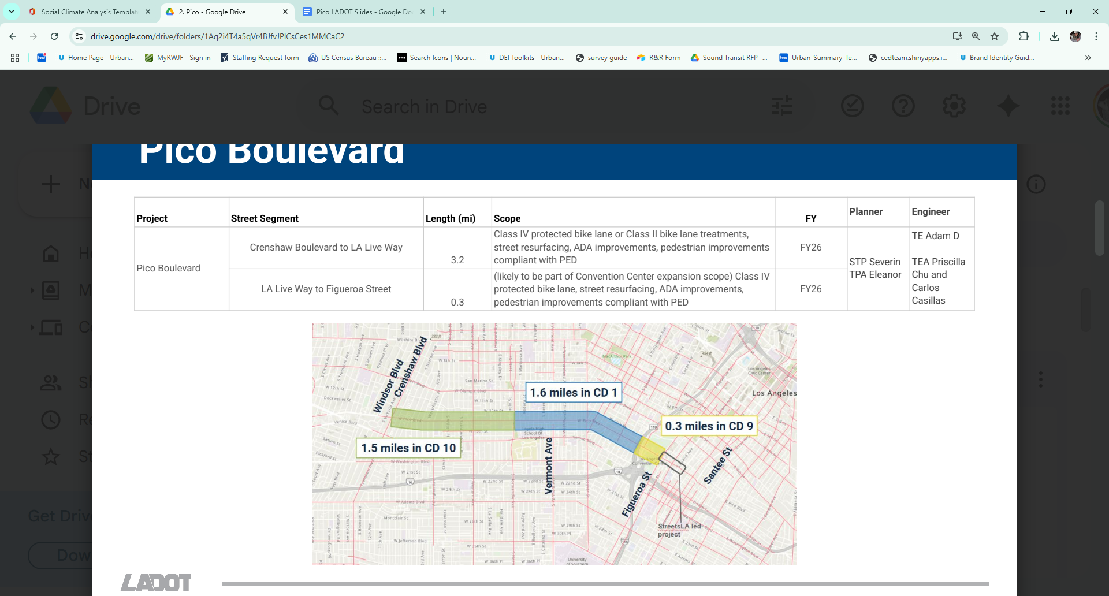Pico Boulevard Safety and Connectivity Project Boundaries

In May 2019, LADOT implemented a set of basic safety improvements between Union Avenue and 2nd Avenue. These enhancements included new traffic signals, upgraded continental crosswalks, and minor crosswalk improvements on side streets. Additional updates followed later that year. More information on these efforts can be found on LADOT’s project pages (<https://ladotlivablestreets.org/projects/Pico-Boulevard-Western-to-Union-Safety-Improvements> and <https://ladotlivablestreets.org/projects/pico-western-2nd-ave).>

In early 2024, LADOT presented a preliminary concept for a corridor redesign to City Council Districts 1 and 10. This redesign aims to reconfigure the corridor and add bike lanes, improving multimodal safety and filling gaps in the City’s bicycle network. Pico Boulevard has since been designated as an Olympics-serving priority corridor, intended to enhance access to the Convention Center in Downtown Los Angeles.

The current Pico Boulevard Safety and Mobility Project spans approximately 3.5 miles from Crenshaw Boulevard to Figueroa Street. The primary goals are to improve safety, reduce the frequency and severity of collisions, and strengthen bicycle connections across the city. A major focus of the project is to close a gap in the City’s bicycle network by implementing bike lanes that would link existing facilities on 4th Avenue and Figueroa Street.

The Project is intended to improve safety on Pico Boulevard and reduce the number of severe and fatal collisions occurring on the street. The Project is also intended to close a gap in the City’s bicycle network by implementing bike lanes on Pico between Crenshaw Boulevard and Figueroa Street, connecting to existing bike lanes on 4th Avenue and Figueroa Street.

To achieve these goals, LADOT is considering multiple design alternatives for different segments of the corridor. More specifically, they are considering two alternatives to achieve the project goal between Crenshaw Boulevard and Bond Street by converting Pico from its existing two lanes in each direction with parallel parking and left turn pockets:

* 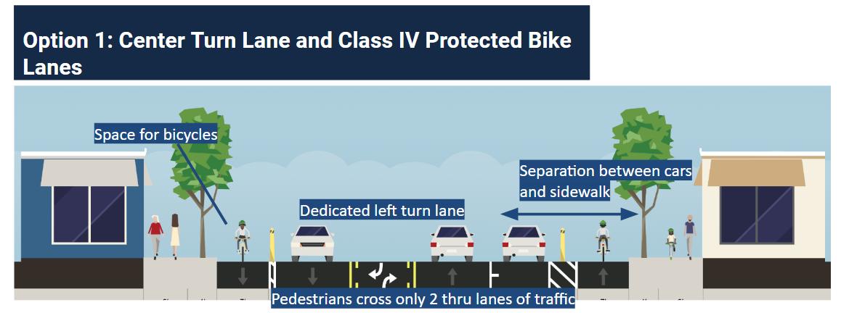**Option 1:** A single lane in each direction with a continuous center left turn lane, parallel parking on one side of the street plus Class IV protected bike lanes on both sides of the street.
* **Option 2:** A single lane in each direction with a continuous center turn lane, parallel parking on both sides plus Class II bike lanes in each direction. This option includes speed tables.

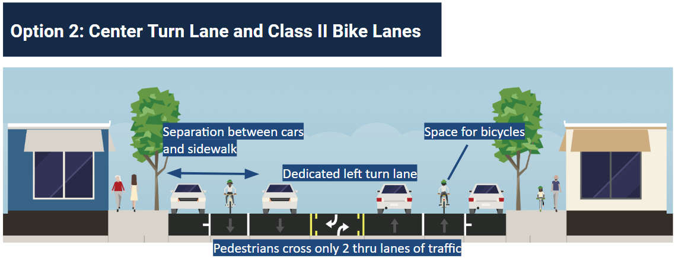

Between Bond Street and Figueroa Street, the project proposes to convert Pico Boulevard from two lanes in each direction with right turn lanes to two lanes in each direction with Class IV protected bike lanes. The project could also include additional safety measures from the Vision Zero toolkit such as left turn calming, speed tables, and pedestrian refuge islands. Outreach will occur over about a 7-month period and the project will be implemented in Fiscal Year 2024-2025. Further design details may be informed based on the community engagement process and more detailed collision analysis.

The overall timeline for the project includes one month for planning, followed by the launch of community engagement in the second month. Engagement activities will continue through months three and four. In months five and six, LADOT will finalize the design and share it with the community for feedback. Implementation is anticipated in the seventh month. Post-implementation evaluation will include short-term adjustments within the first three months and a full safety assessment after approximately 1.5 years, once updated collision data becomes available.

Previous engagement along Pico Boulevard includes a 2017 Vision Zero community open house. LADOT also conducted outreach in the broader area as part of a Safe Routes to School initiative serving Berendo Middle School, Liechty Middle School, and Los Angeles Elementary. However, overall engagement efforts have been sporadic and lack consistent documentation.

The project falls within Council Districts 1, 9, and 10 and is currently in the planning and design phase. It is classified as a Level 3b project, which refers to major efforts that significantly impact multiple neighborhoods and council districts and involve notable tradeoffs. A project website is forthcoming, and additional design updates will be made available as the engagement process progresses.

* Indicate all city agencies responsible for project delivery and the components that they are responsible for.

# Section One: Project Area and Community Background

To design equitable and effective community engagement strategies, it is critical to understand the socio-economic conditions and lived experiences of residents within the Project Study Area—defined here as the ½-mile radius surrounding Pico Boulevard from Crenshaw Boulevard to Figueroa Street.1 This section provides a comprehensive demographic and socioeconomic profile of the area, drawing from the 2019–2023 American Community Survey and other publicly available datasets.

By analyzing indicators related to language access, income and poverty, housing stability, transportation patterns, and other accessibility considerations, we aim to:

* Highlight key community needs that may influence mobility and infrastructure outcomes;
* Inform culturally and contextually appropriate outreach and engagement approaches; and
* Ensure that LADOT’s programs and investments are responsive to the specific dynamics of the neighborhoods served.

The analysis includes both quantitative data visualizations (such as bar charts and maps) and contextual interpretation to better understand disparities, risks of displacement, and access to resources. In doing so, this section lays the foundation for equity-focused planning and engagement throughout the project.

## Demographic Profile

* A total of 151,225 people reside in the Pico Study Area. In most census tracts within the corridor, the population ranges from 2,000 to 4,000, save for one outlier (figure 1). More than 7,000 people live in census tract 2079.02, which is located in the Easternmost portion of the corridor by the city’s fashion district (figure 2).

Figure 1

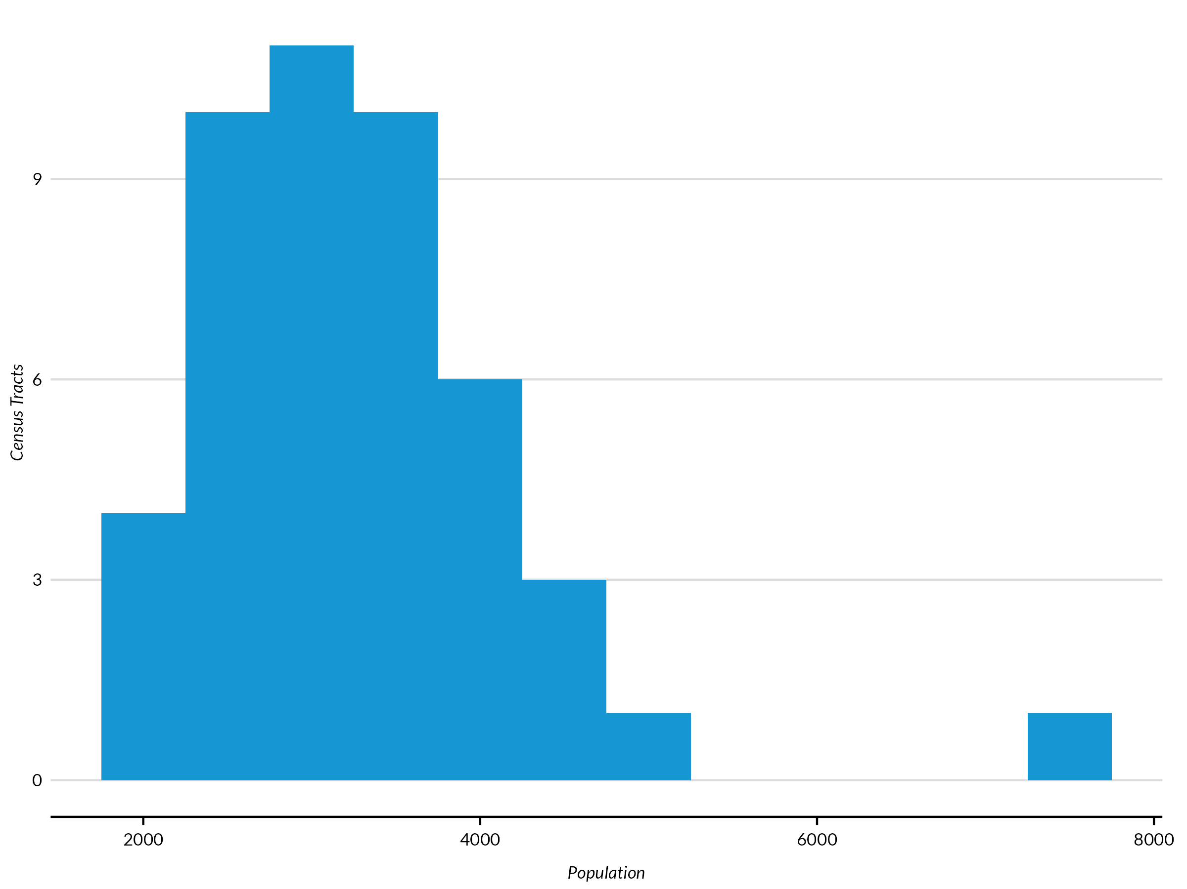Population Distribution in the Pico Study Area

**Source:** Authors’ analysis of 2019-2023 American Community Survey data table B01001, ‘Sex by Age’.

FIGURE 2

Population in the Pico Study Area by Census Tract

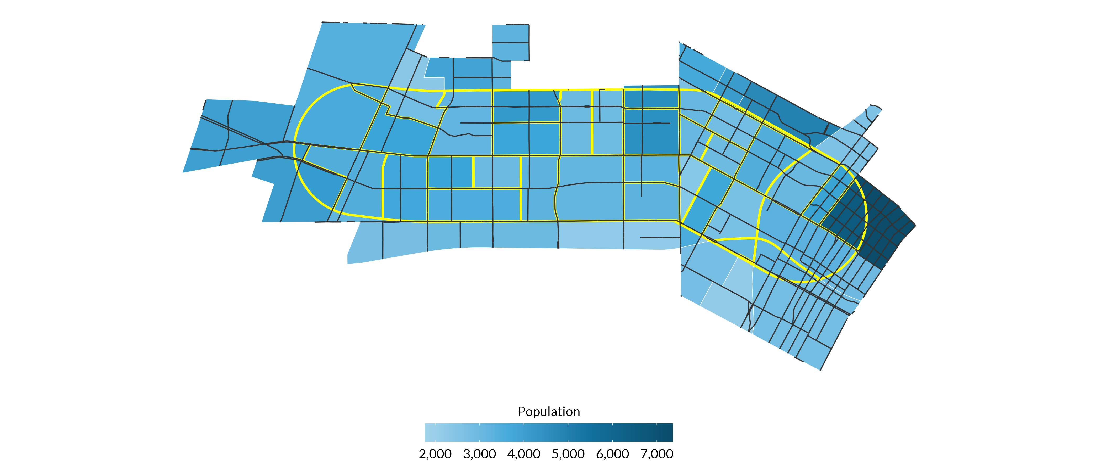**Source:** Authors’ analysis of 2019-2023 American Community Survey data table B01001, ‘Sex by Age’.

Figure 3 highlights the age distribution among residents in the Pico Study Area, which we split into the groups that most closely align with generational cut points. More than 38,000 residents are between the ages of 30-44, which largely aligns with the Millennial generation. The population is otherwise spread relatively evenly across other generations.

FIGURE 3

Age Distribution

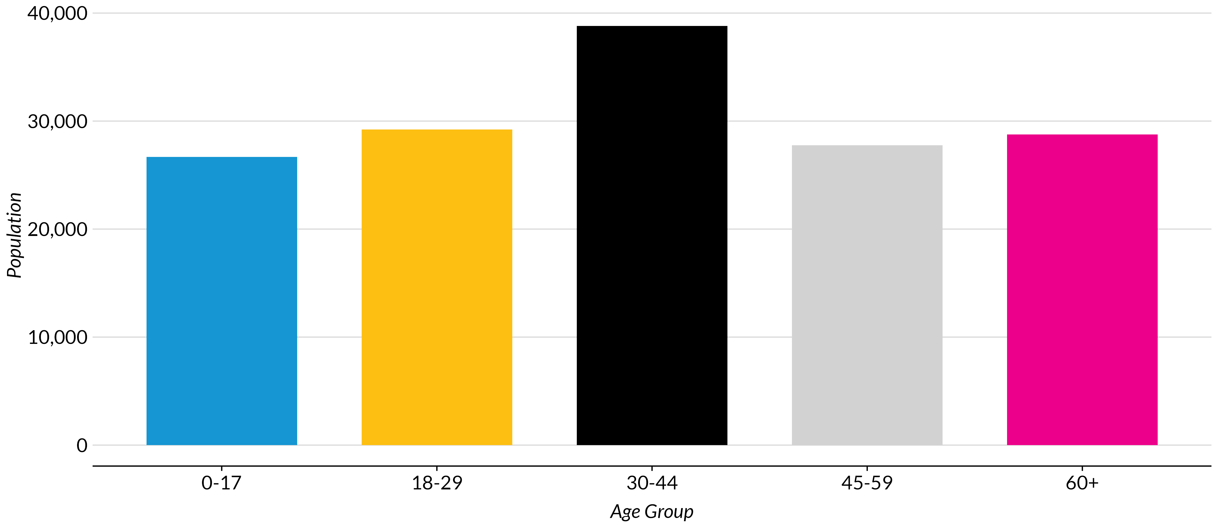**Source:** Authors’ analysis of 2019-2023 American Community Survey data table B01001, ‘Sex by Age’.

**Notes:** These age brackets were selected to approximate the widely accepted bounds for generations. These do not completely align due to the brackets collected by the U.S. Census Bureau. 0-17 represents Generation Alpha (ages 0-12) and the younger end of Generation Z (ages 12-27); 18-29 represents the older end of Generation Z; 30-44 represents Generation Y or Millennials (ages 28-43); 45-59 represents Generation X (ages 44-59); and 60+ represents Baby Boomers (ages 60-78) and the Silent Generation (ages 79-100).

As seen in Figure 4, a plurality of residents in the Pico Study Area identify as Hispanic or Latino (57 percent). A little over one-fifth of residents identify as Asian (21 percent), while under 10 percent of residents each identify as White (9.7 percent) or Black (9.1 percent).

FIGURE 4

Ethnicity in the Pico Study Area

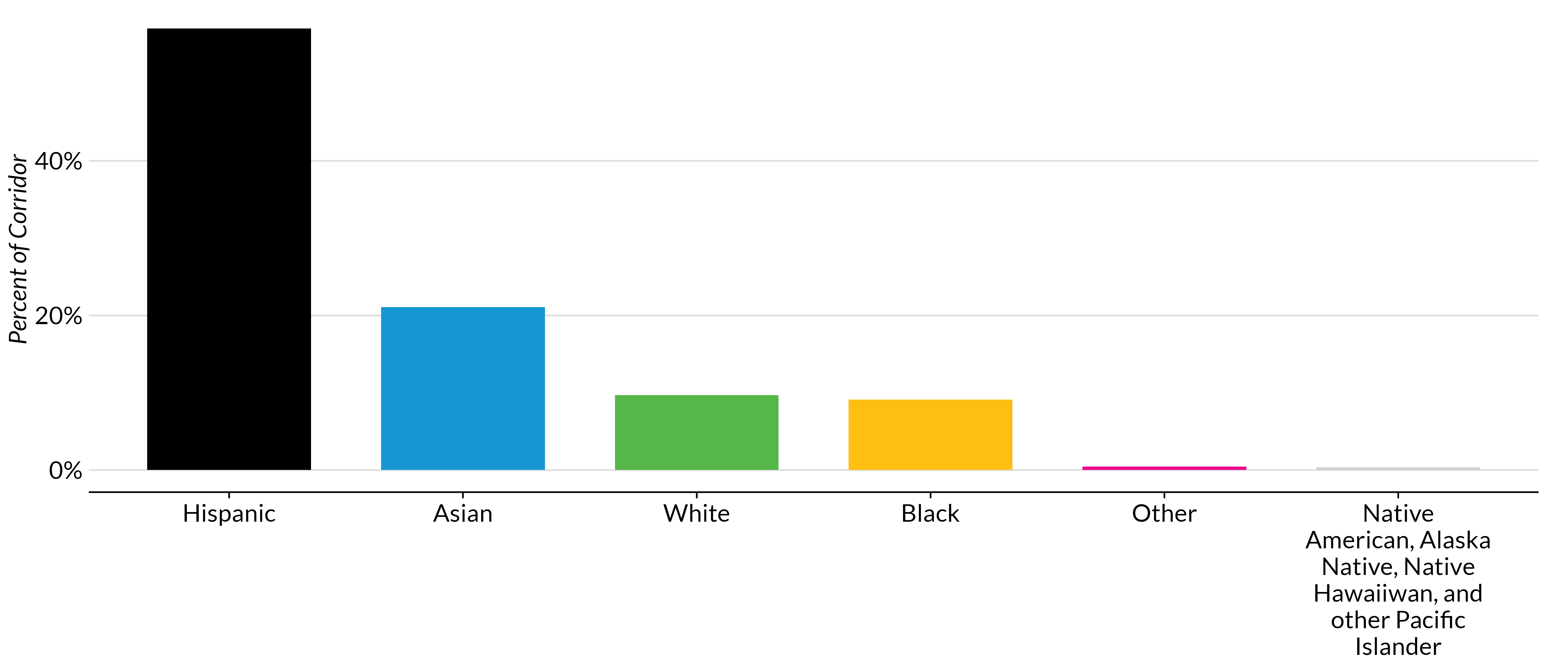**Source:** Authors’ analysis of 2019-2023 American Community Survey data table B03002, ‘Hispanic or Latino Origin by Race’.

Looking at residents’ income levels, a majority of census tracts have a median household income around or below $50,000 (figure 5). Only two tracts have a median household income greater than $100,000 (2077.11 and 2079.02), and both are located in the easternmost part of the corridor, bordering each other.

FIGURE 5

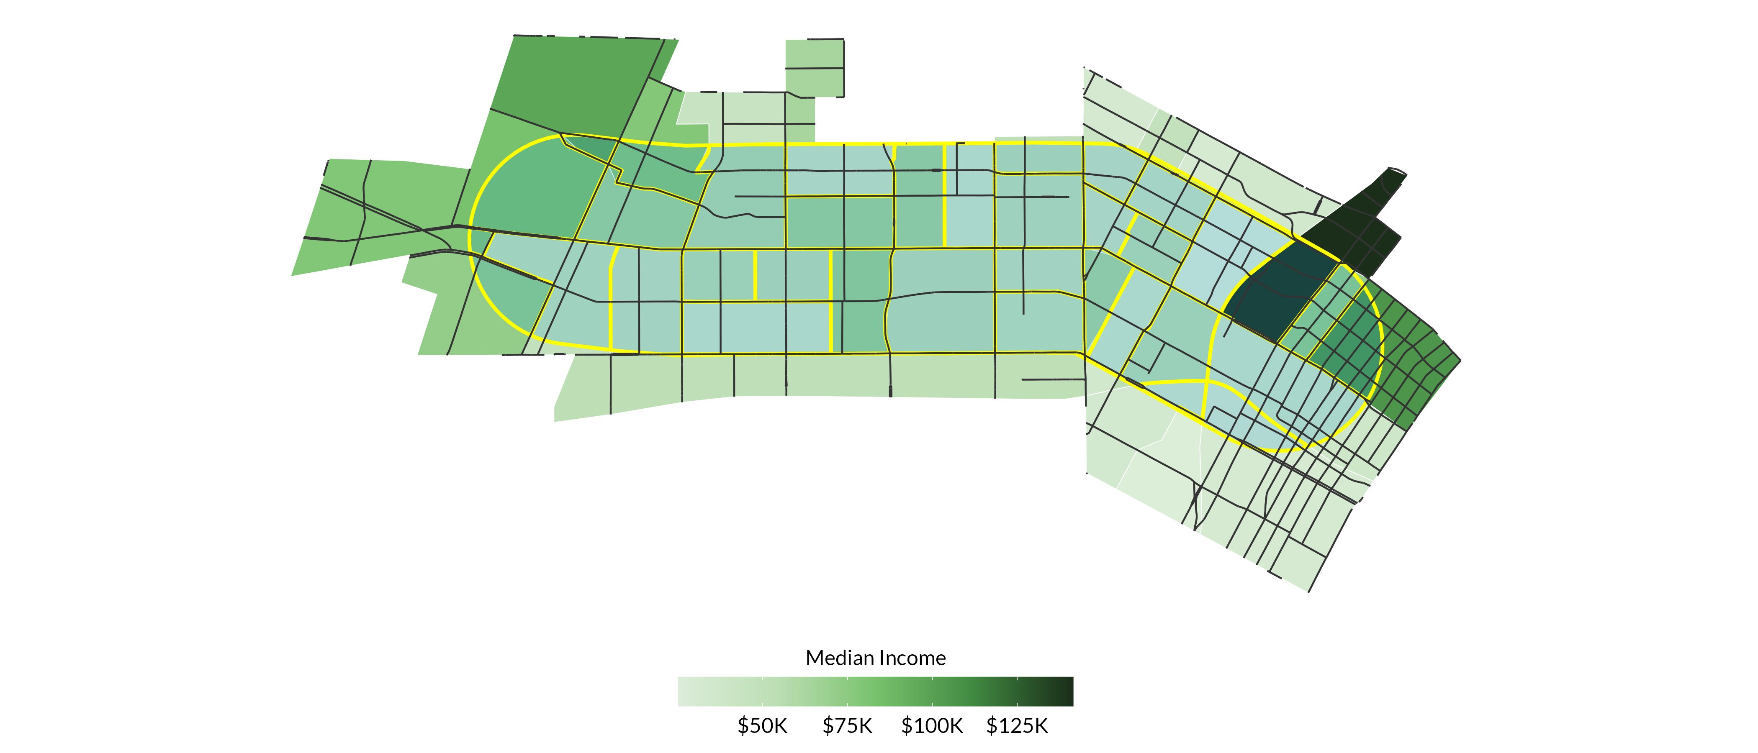Median Income by Census Tract

**Source:** Authors’ analysis of 2019-2023 American Community Survey data table B19013, ‘Median Household Income in the Past 12 Months (in 2023 Inflation-Adjusted Dollars)’.

Across the corridor, just under one quarter (24 percent) of the population lives below the federal poverty level. Much of this population is concentrated in the 13 census tracts where more than 30 percent of the population lives below the federal poverty line (figure 6).

FIGURE 6

Population Living Below the Federal Poverty Level by Census Tract

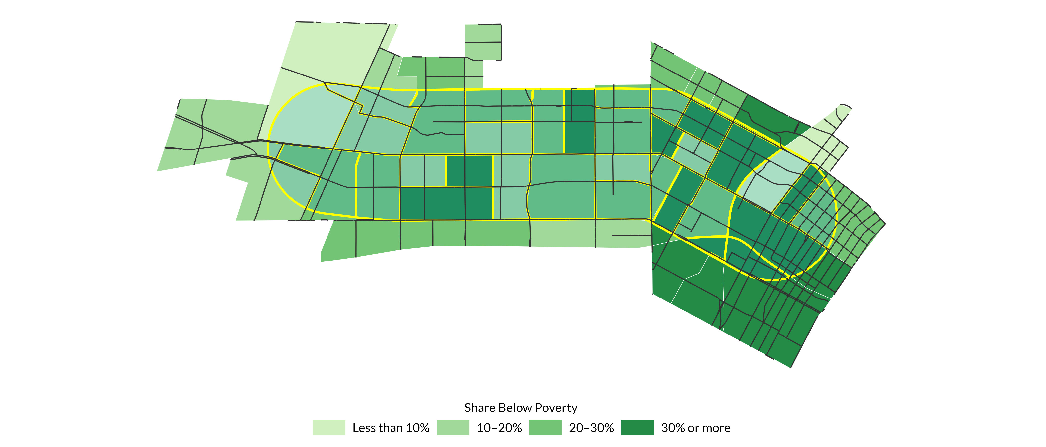**Source:** Authors’ analysis of 2019-2023 American Community Survey data table, B17001, ’Poverty Status in the Past 12 Months by Sex by Age’.

**Notes:** Percentage is based off total population in each census tract.

The majority of residents in the corridor are employed (figure 7), while only 5 percent of residents are unemployed. More than one third (35%) of residents in the corridor over the age of 16 are not in the labor force, meaning they may have greater ability to attend engagement sessions, and as such could be overrepresented in these activities.

FIGURE 7

Employment Status in the Pico Study Area

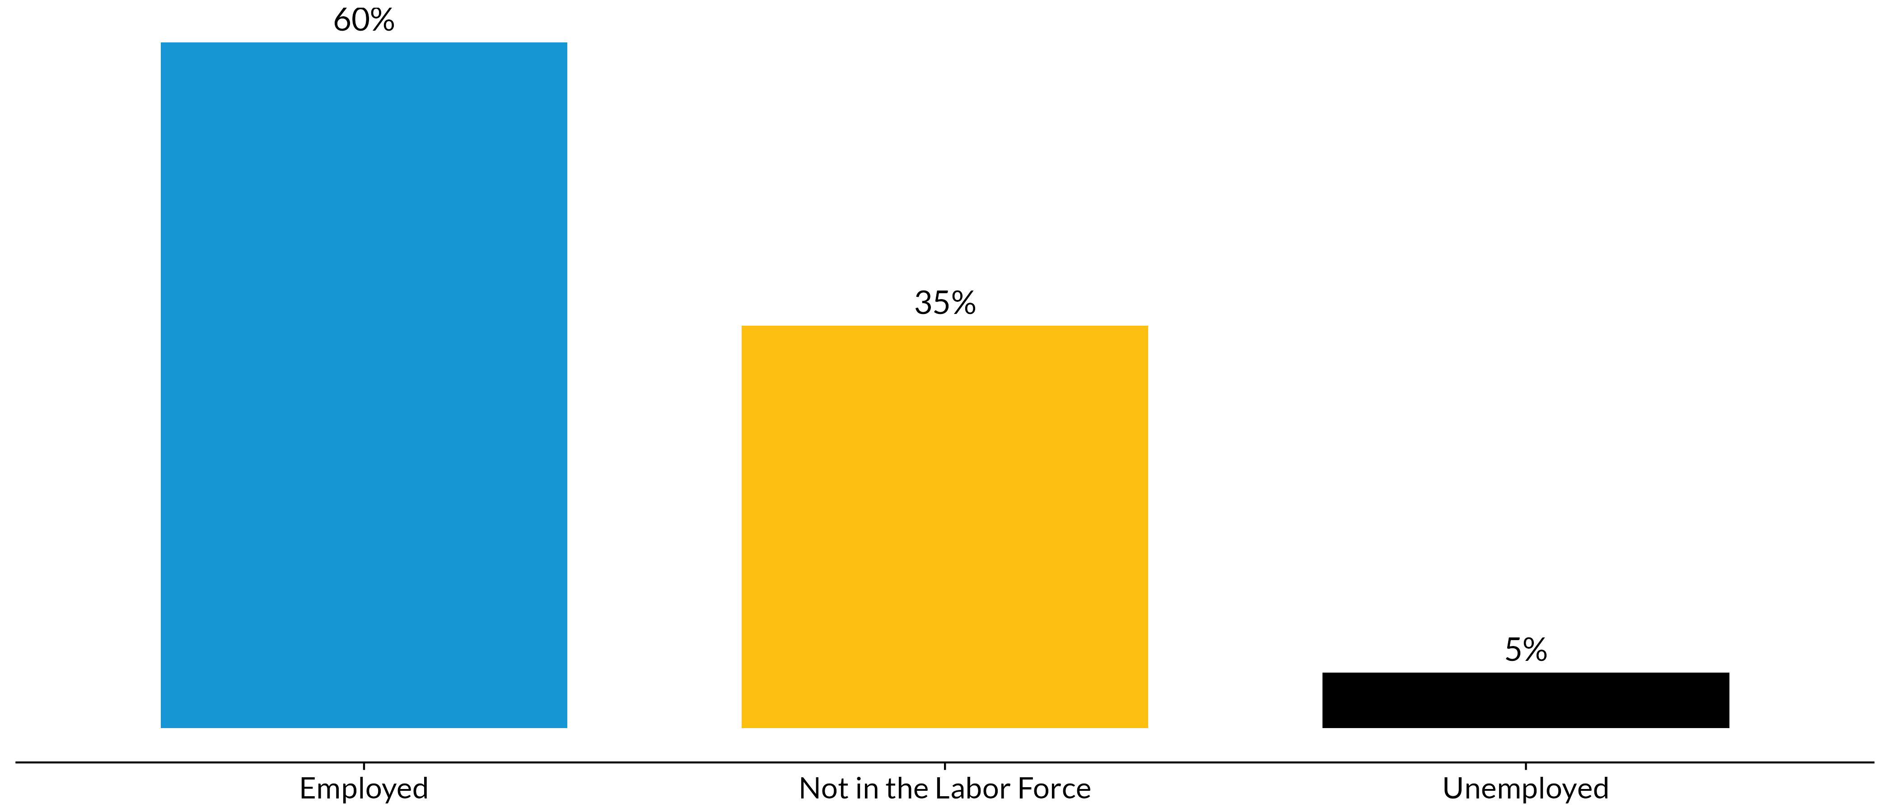**Source:** Authors’ analysis of 2019-2023 American Community Survey data table B23001, ’Sex by Age by Employment Status for the Population 16 Years and Over’.

**Notes:** Percentage is based off total population in the corridor. Data does not include residents in the Armed Forces; just over 0 percent of residents are identified as such.

Much like the rest of the city, state, and country, the Pico Study Areais roughly evenly split by gender (figure 8). Census tract 2094.02 has the highest share of male residents (58.9 percent), while tract 2244.20 has the highest share of female residents (61.7 percent).

FIGURE 8

Gender in the Pico Study Area

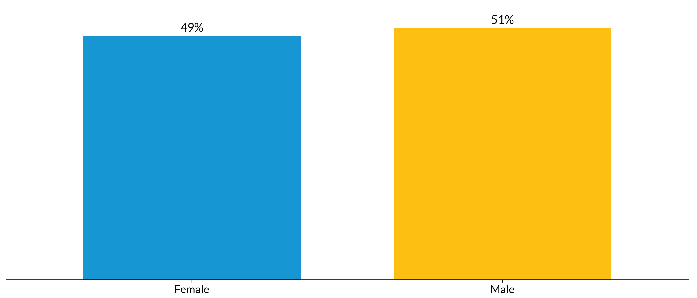**Source:** Authors’ analysis of 2019-2023 American Community Survey data table B01001, ‘Sex by Age’.

**Notes:** Percentage is based off total population in the corridor.

Roughly 12,000 households in the Pico Study Area include children under the age of 18, and just under half (46 percent) of these households are led by single parents (figure 9). While not a substantial portion of the corridor population as a whole, this still suggests that any outreach events or activities, especially those geared to families, should be considerate of the childcare needs of attendees.

FIGURE 9

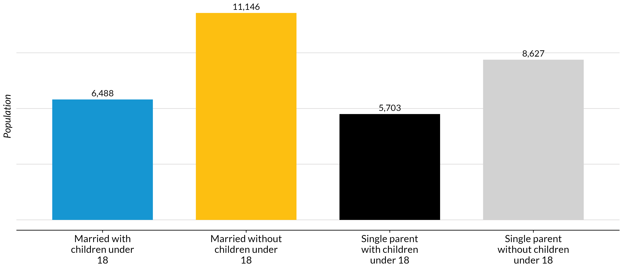Family Structure in the Pico Boulevard Corridor

**Source:** Authors’ analysis of 2019-2023 American Community Survey data table B11003, ‘Family Type by Presence and Age of Own Children Under 18 Years’.

## Language Access and Cultural Considerations

Much like the greater city of Los Angeles, the Pico corridor is a diverse area where residents speak multiple languages, with a varying degree of comfort speaking English (figure 10). The plurality, but not the majority (43%), of the corridor speaks English “very well”, but this is not much greater than the number of people who either speak English “not well” (25%) or “not at all” (13%). As a result, outreach materials should not rely exclusively on English, and those that do should present it in more basic and understandable language.

Of the alternative language options, Spanish language materials should clearly be prioritized, as more than half of residents along the corridor speak Spanish (figure 11). While these residents may also speak English, a clear majority of the corridor has some level of Spanish proficiency. Meanwhile, just over 13% of residents speak Korean. Another 2% speak Chinese, and 5% speak other languages.

FIGURE 10

English Speaking Ability in the Pico Boulevard Corridor

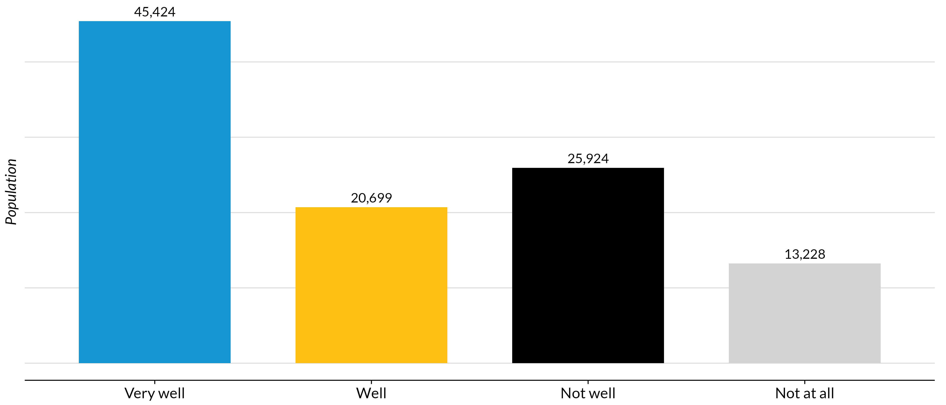**Source:** Authors’ analysis of 2019-2023 American Community Survey data table B16004, ’Age by Language Spoken at Home by Ability to Speak English for the Population 5 Years and Over’.

FIGURE 11

Other Languages Spoken in the Pico Boulevard Corridor

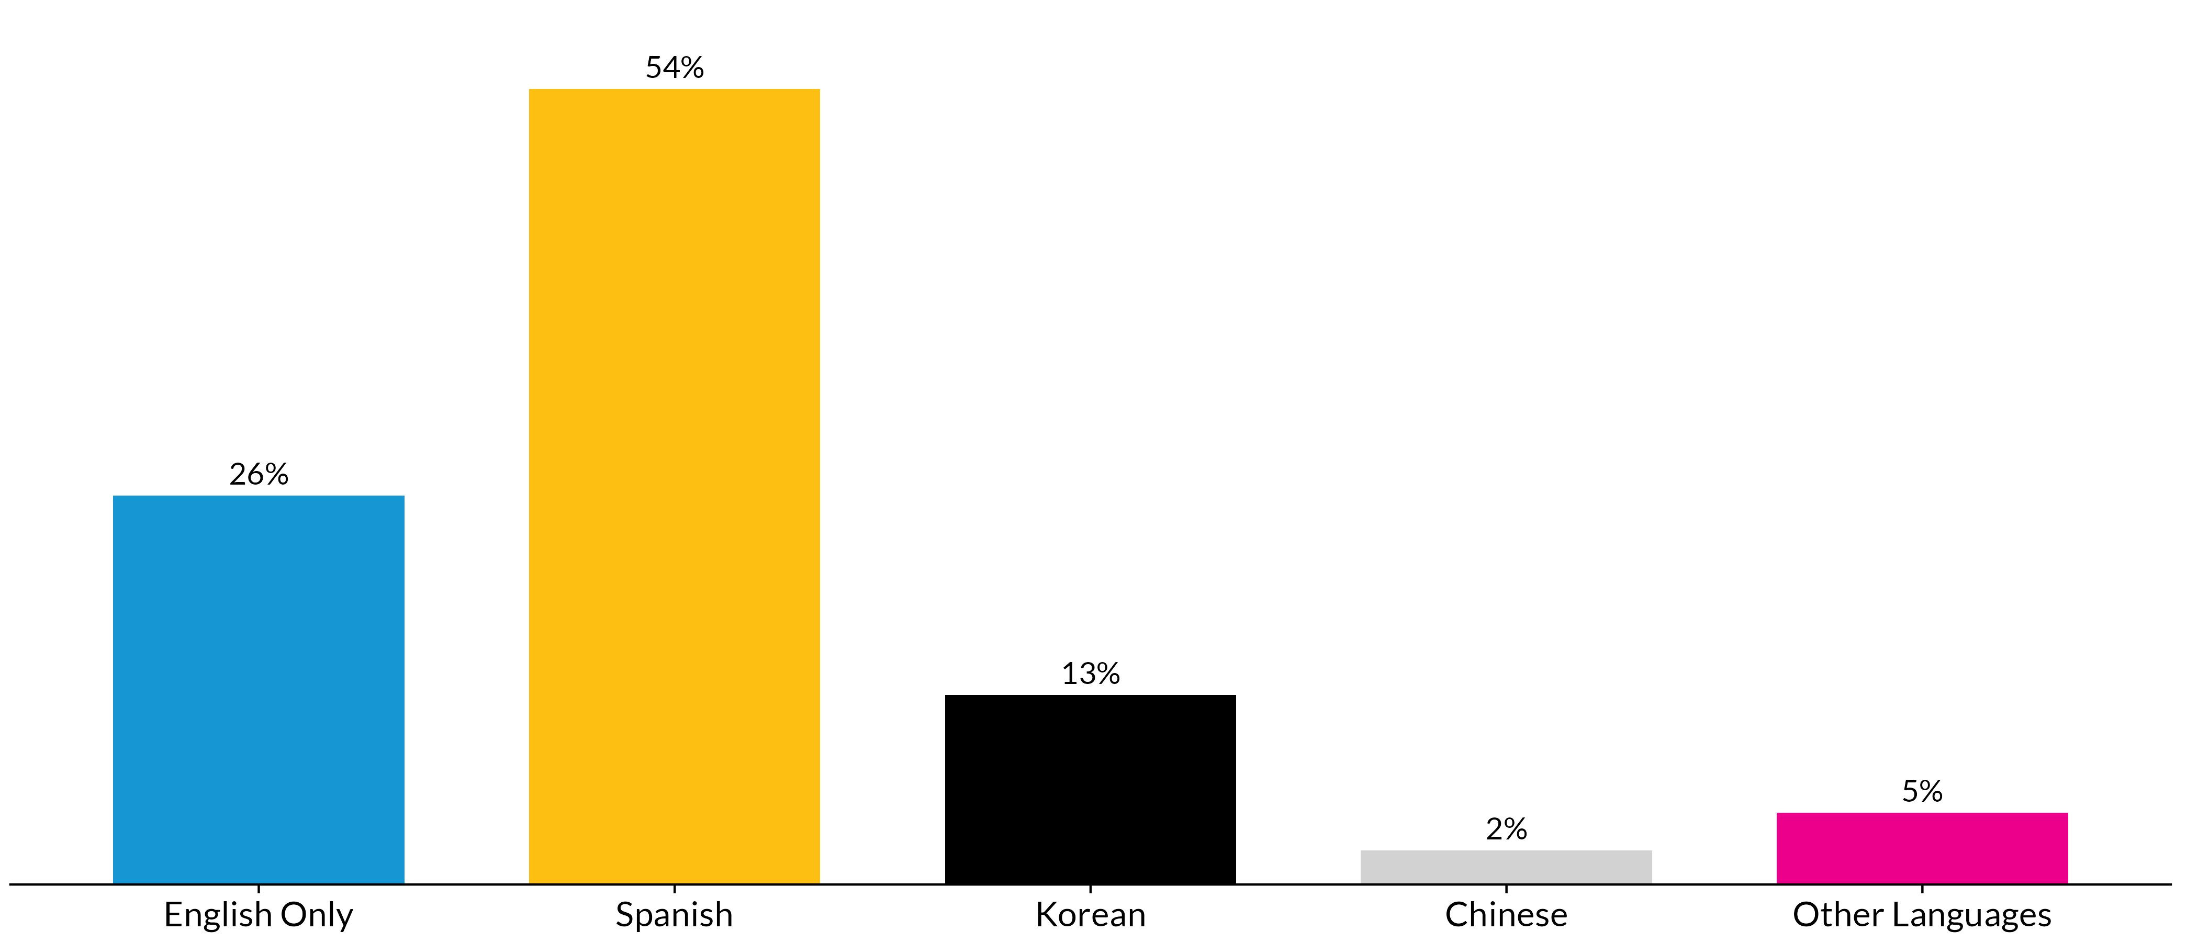**Source:** Authors’ analysis of 2019-2023 American Community Survey data table C16001, ’Language Spoken at Home for the Population 4 Years and Over’.

When mapping the location of households where other languages are spoken, there are clear concentrations by language. In almost every tract in the Pico corridor, at least one fifth of households are Spanish-speaking (figure 12). Yet tracts in the eastern portion of the corridor have significantly higher concentrations of Spanish speakers than those in the western portion. Meanwhile, there is no one census tract where more than 50 percent of households speak Korean (figure 13), but there are three in the western portion of the corridor where more than 40 percent of households do.

FIGURE 12

Spanish-Speaking Population by Census Tract

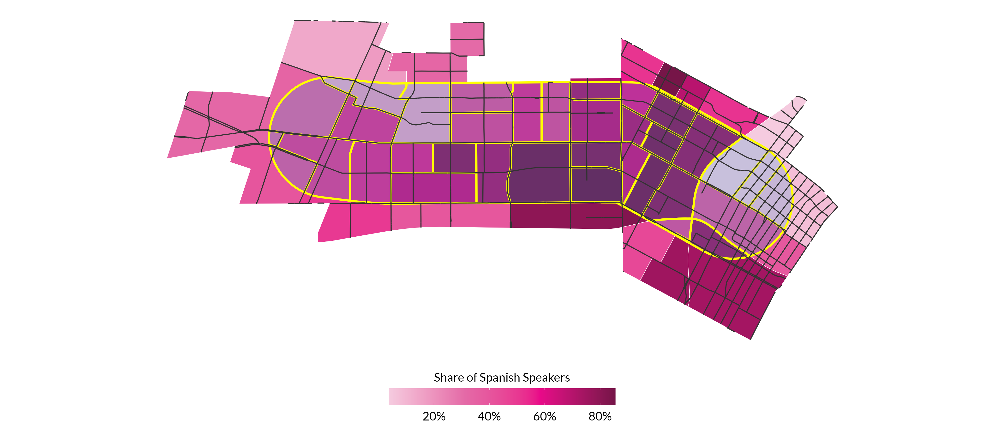**Source:** Authors’ analysis of 2019-2023 American Community Survey data table C16001,’Language Spoken at Home for the Population 4 Years and Over’.

**Notes:** Percentage is based off total population in each census tract.

FIGURE 13

Korean-Speaking Population by Census Tract

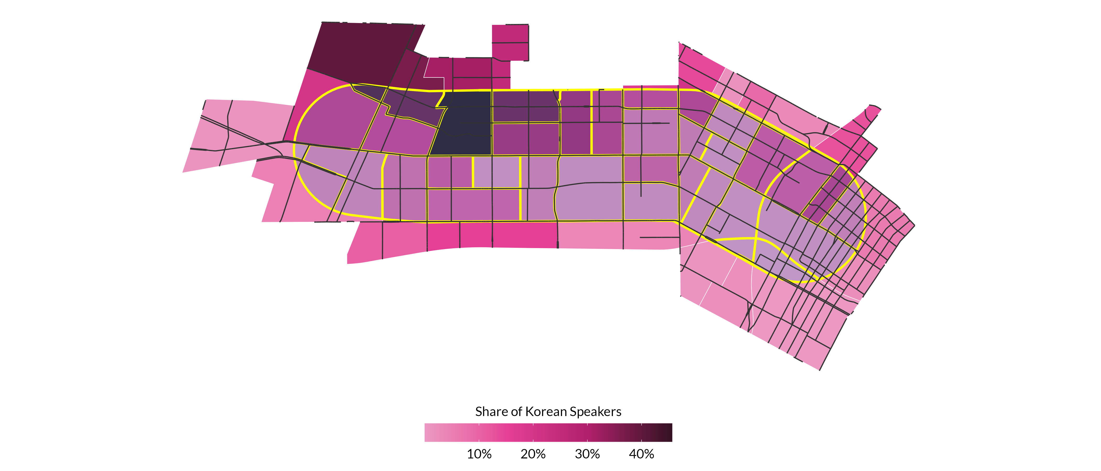 **Source:** Authors’ analysis of 2019-2023 American Community Survey data table C16001, ’Language Spoken at Home for the Population 4 Years and Over’.

**Notes:** Percentage is based off total population in each census tract.

According to Census estimates, just under half (48 percent) of residents in the corridor were born in a country outside of the United States. Roughly 20,000 of these residents come from Mexico, which is more than one quarter of the total foreign-born population (Table 1). Close behind is Korea, where around 16,000 residents originate from, suggesting that Asian language materials may predominately be in Korean, while some could be in Chinese (3,537 residents from China) or even Filipino (1,764 residents). Other Central American countries represented in the corridor include El Salvador (11,581 residents), Guatemala (10,155 residents), and Honduras (1,608 residents).

Table 1

Most Popular Countries of Origin in the Pico Boulevard Corridor

|  |  |
| --- | --- |
| **Country** | **Population** |
| Mexico | 20,140 |
| Korea | 16,057 |
| El Salvador | 11,581 |
| Guatemala | 10,155 |
| China | 3,537 |
| Philippines | 1,764 |
| Honduras | 1,608 |

**Source:** Authors’ analysis of 2019-2023 American Community Survey data table B05006, ‘Place of Birth for the Foreign-Born Population in the United States’.

**Notes:** Table includes all of the countries with a population greater than 1,000

## Other Accessibility Considerations

Another important consideration when conducting community engagement is whether there are residents with mobility limitations or other disabilities in the community. Similar to the rest of Los Angeles County, approximately 11 percent of residents in the Pico Boulevard corridor have a disability. However, individuals with disabilities do not tend to live uniformly across census tracts. Rather, individuals with disabilities are more likely to live in certain tracts in the western, northeastern, and southeastern areas of Pico Boulevard (Figure 14). In several cases, over 15 percent of a tract’s population has a disability, and there are nine census tracts where over 500 individuals have a disability. However, because of small sample sizes, disability estimates at the census tract level are subject to large margins of error and should be interpreted with caution.

FIGURE 14

Number of Individuals with a Disability, by Census Tract

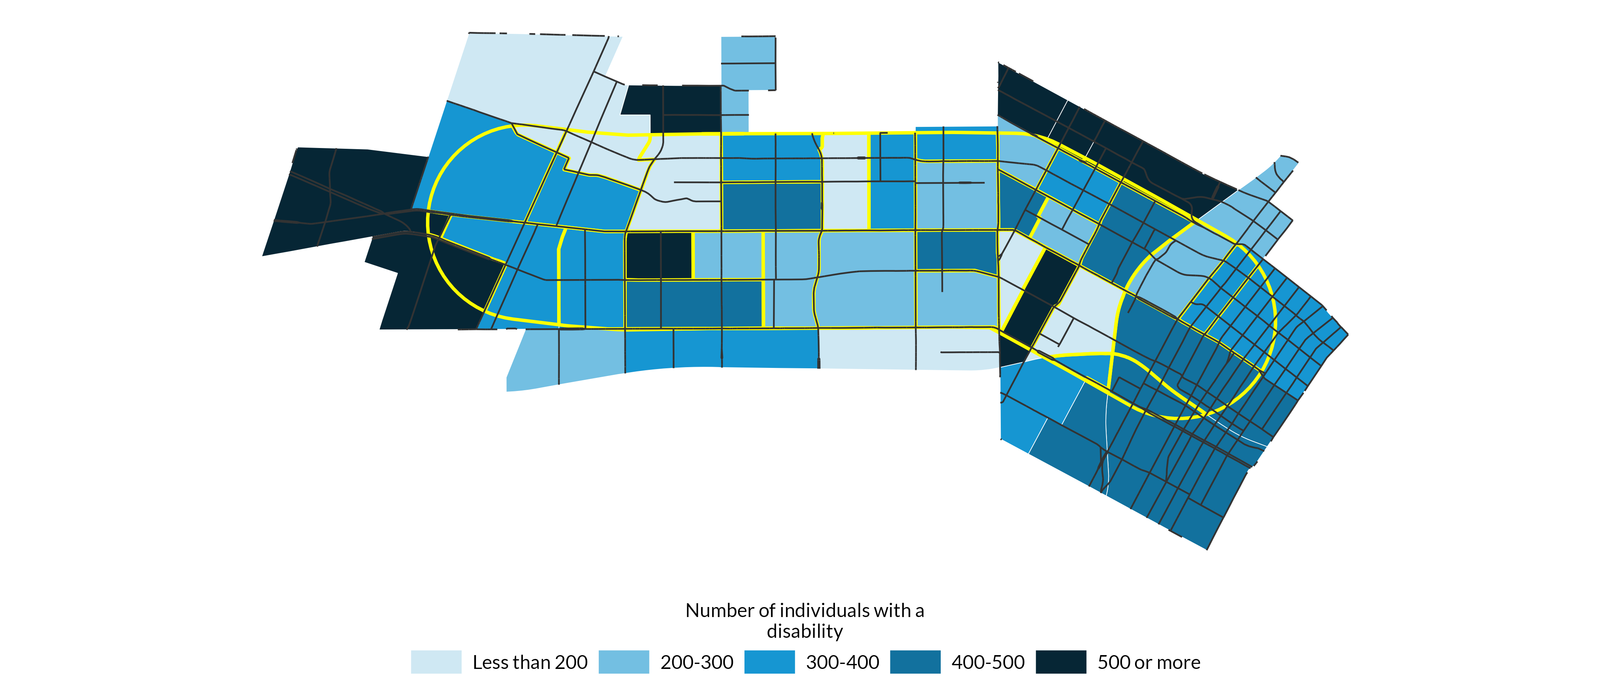**Source:** Authors’ analysis of 2019-2023 American Community Survey data table B18101, ‘Sex by Age by Disability Status’.

There is also substantial variation between census tracts with respect to the number of individuals with a vision difficulty (Figure 15). Though the median census tract in the Pico Boulevard corridor has 65 individuals with a vision difficulty, as few and zero and as many as 243 individuals have a vision impairment across the corridor. The skew in the distribution of individuals with vision difficulties across tracts is driven by a subset of census tracts with a high number of individuals with a vision impairment. For instance, a concentration of census tracts in the eastern part of the Pico Boulevard corridor have over 150 individuals with a vision impairment in each tract.

A similar pattern emerges when observing the number of individuals with a hearing difficulty across census tracts. While fewer than three percent of individuals have a hearing difficulty in most census tracts, a handful of tracts have a much higher concentration of hearing-impaired individuals (Figure 16). Eleven census tracts have over 100 individuals with a hearing difficulty, with the highest number being 256.

FIGURE 15

Number of Individuals with Vision Difficulty, by Census Tract

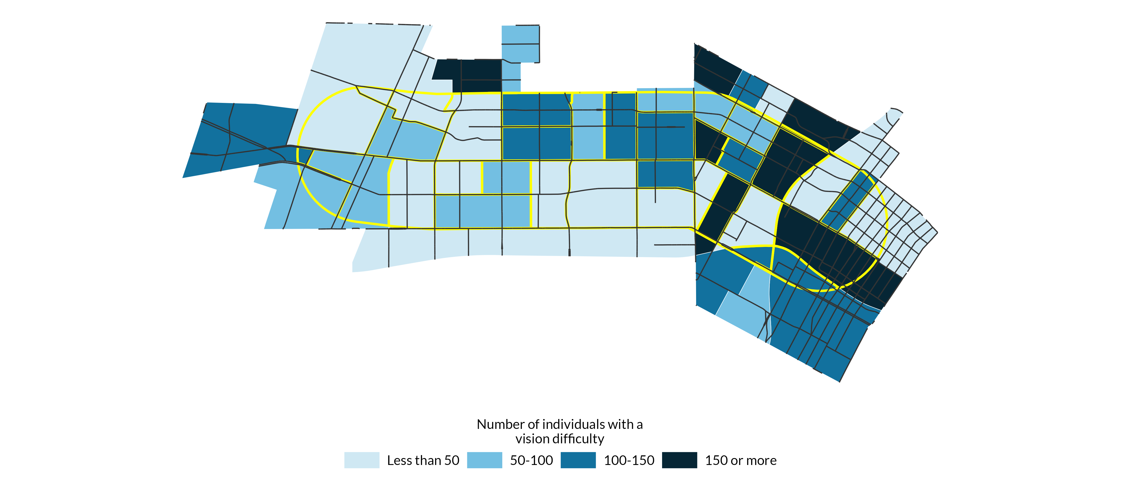**Source:** Authors’ analysis of 2019-2023 American Community Survey data table B18103, ’Sex by Age by Vision Difficulty’.

FIGURE 16

Number of Individuals with Hearing Difficulty, by Census Tract

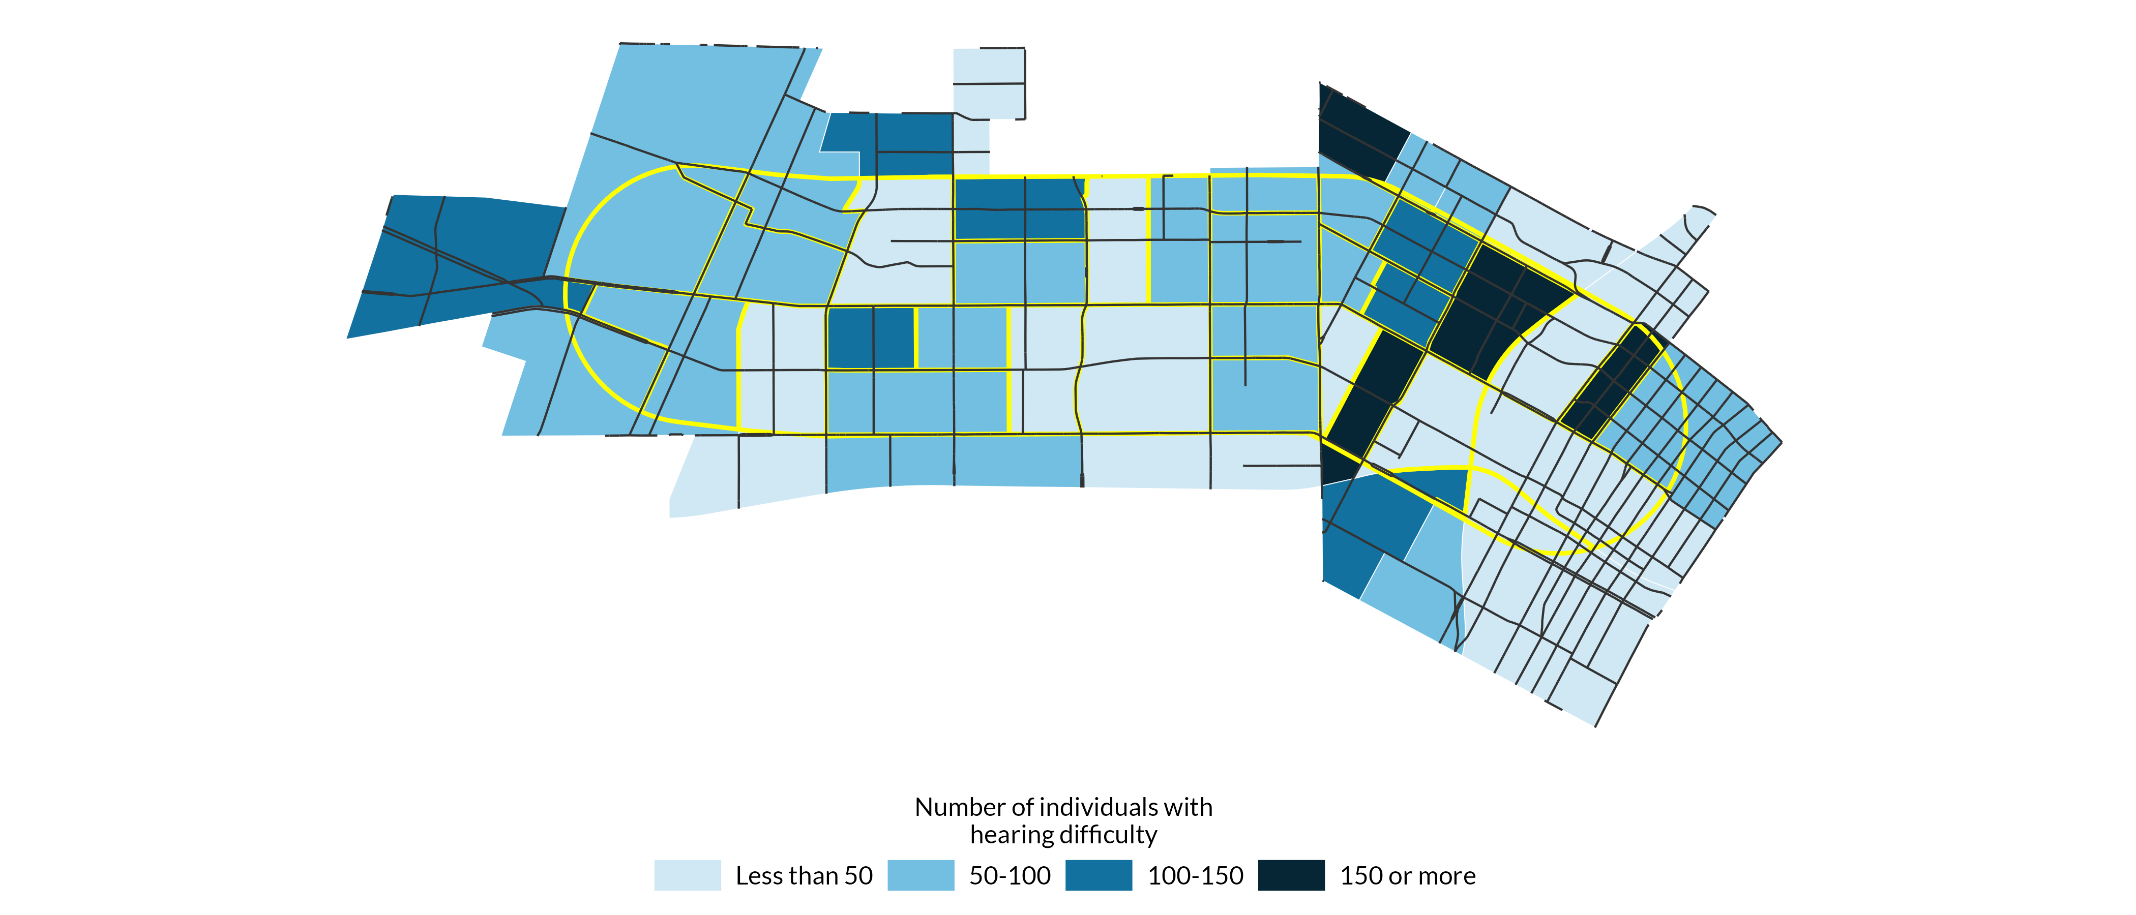**Source:** Authors’ analysis of 2019-2023 American Community Survey data table B18102, ’Sex by Age by Hearing Difficulty’.

Individuals with an ambulatory difficulty, or serious difficulty walking or climbing stairs, are more uniformly located across census tracts in comparison to other types of disabilities. But while individuals with an ambulatory difficulty tend to live in all locations, there are still specific census tracts where they are more likely to live. Similar to the patterns of other disabilities, census tracts in the western, northeastern, and southeastern parts of the Pico Boulevard corridor have a higher number of individuals with an ambulatory difficulty (Figure 17).

FIGURE 17

Number of Individuals with an Ambulatory Difficulty, by Census Tract

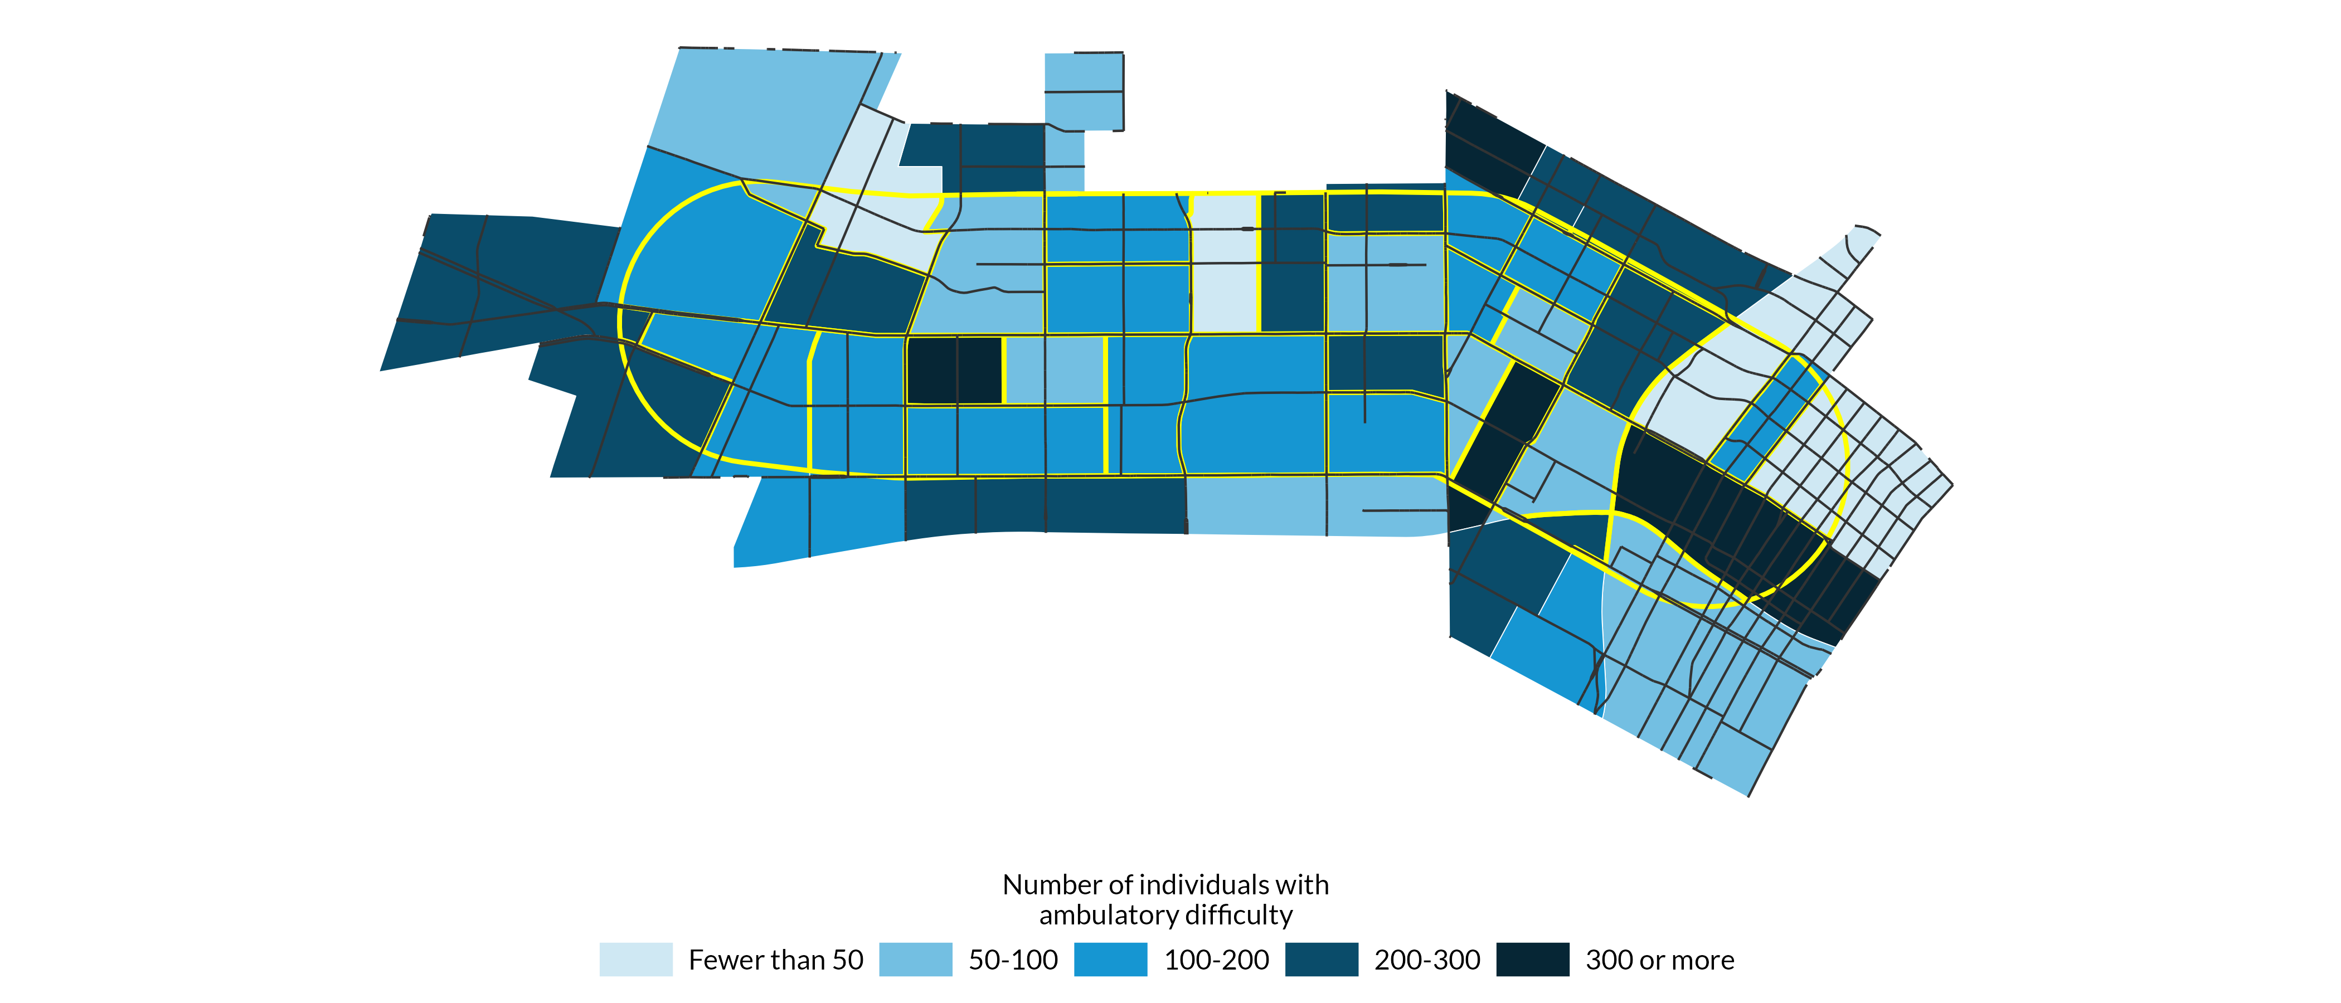**Source:** Authors’ analysis of 2019-2023 American Community Survey data table B18105, ’Sex by Age by Ambulatory Difficulty’.

Access to broadband and technology is essential for enabling individuals to be aware of changes in their community as well as for ensuring that outreach methods are accessible to all. Yet, there are large disparities in access to internet across census tracts in the Pico Boulevard corridor. While the western portion of the corridor generally has high levels of internet access, many areas in the eastern half lack access (Figure 18). For instance, there are several tracts in the eastern portion of the corridor where over 20 percent of households lack access to internet, and there are three census tracts where at least 30 percent of households lack access.

A similar pattern emerges when observing the spatial pattern of households without access to a device (Figure 19). There are ten census tracts where over 10 percent of households lack access to a device. These tracts are predominantly concentrated in the eastern portion of the corridor.

FIGURE 18

Share of Households without Internet Access, by Census Tract

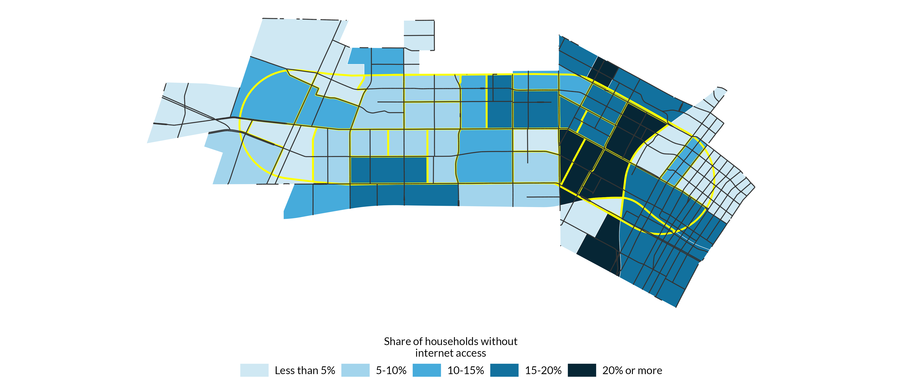**Source:** Authors’ analysis of 2019-2023 American Community Survey data table B28002, ’Presence and Types of Internet Subscriptions in Households’.

**Notes:** Percentage is based off total population in each census tract.

FIGURE 19

Share of Households Without Access to a Device, by Census Tract

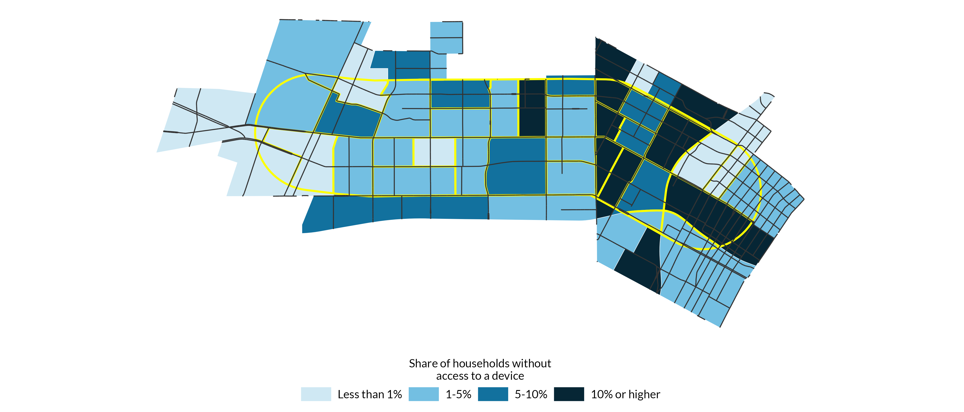**Source:** Authors’ analysis of 2019-2023 American Community Survey data table B28001, ’Types of Computers in Household’.

**Notes:** Percentage is based off total population in each census tract. Device is defined as a desktop or laptop, smartphone, tablet or other portable wireless computer, or other computer.

Across all census tracts in the Pico Boulevard corridor, 95 percent of households have access to a device (Figure 20). The most common type of device that households have access to is a smartphone (91 percent), followed by a computer (73 percent) and a tablet or other mobile device (58 percent). While many households own multiple types of devices, approximately 15 percent only have access to a smartphone. This number is just over one percent for computers and less than one percent for tablets.

FIGURE 20

Device Access Across All Census Tracts

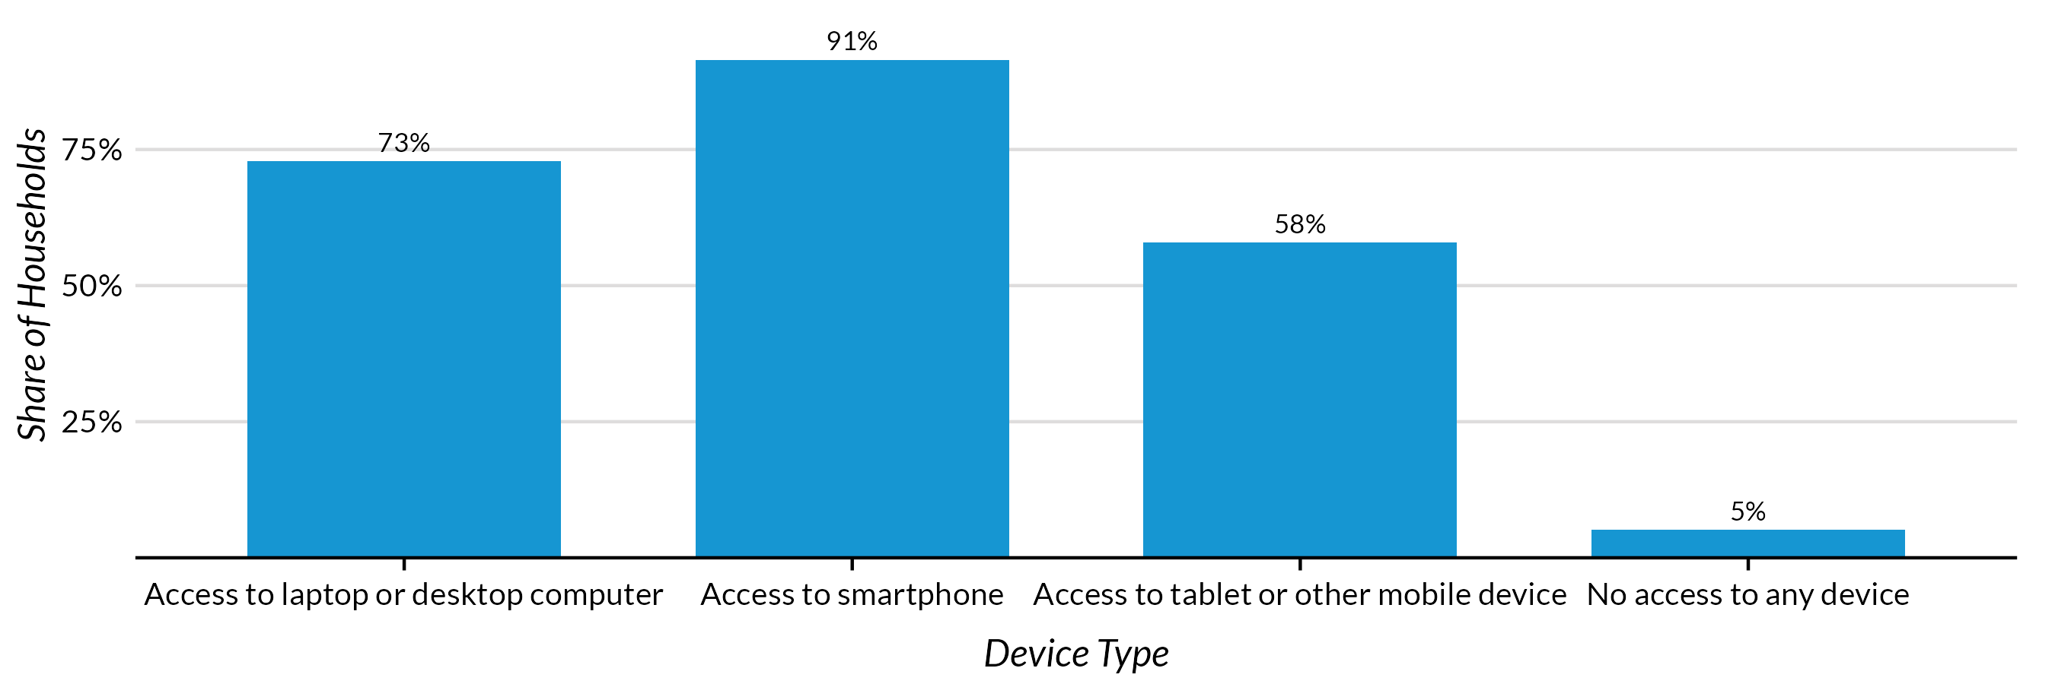**Source:** Authors’ analysis of 2019-2023 American Community Survey data table B28001, ’Types of Computers in Household’.

**Notes:** Percentage is based off total population in the corridor.

## Housing and displacement risk

In all census tracts in the Pico Boulevard corridor, the majority of households are renters. In the average census tract in the corridor, roughly 86 percent of households are renters. There are 22 census tracts where over 90 percent of occupied housing units are renter-occupied, and one census tract where 100 percent of occupied housing units are. While renter-occupied units are spread out throughout the corridor, they are highly concentrated in the eastern part of the corridor (Figure 21).

FIGURE 21

Share of Occupied Housing Units that are Rented

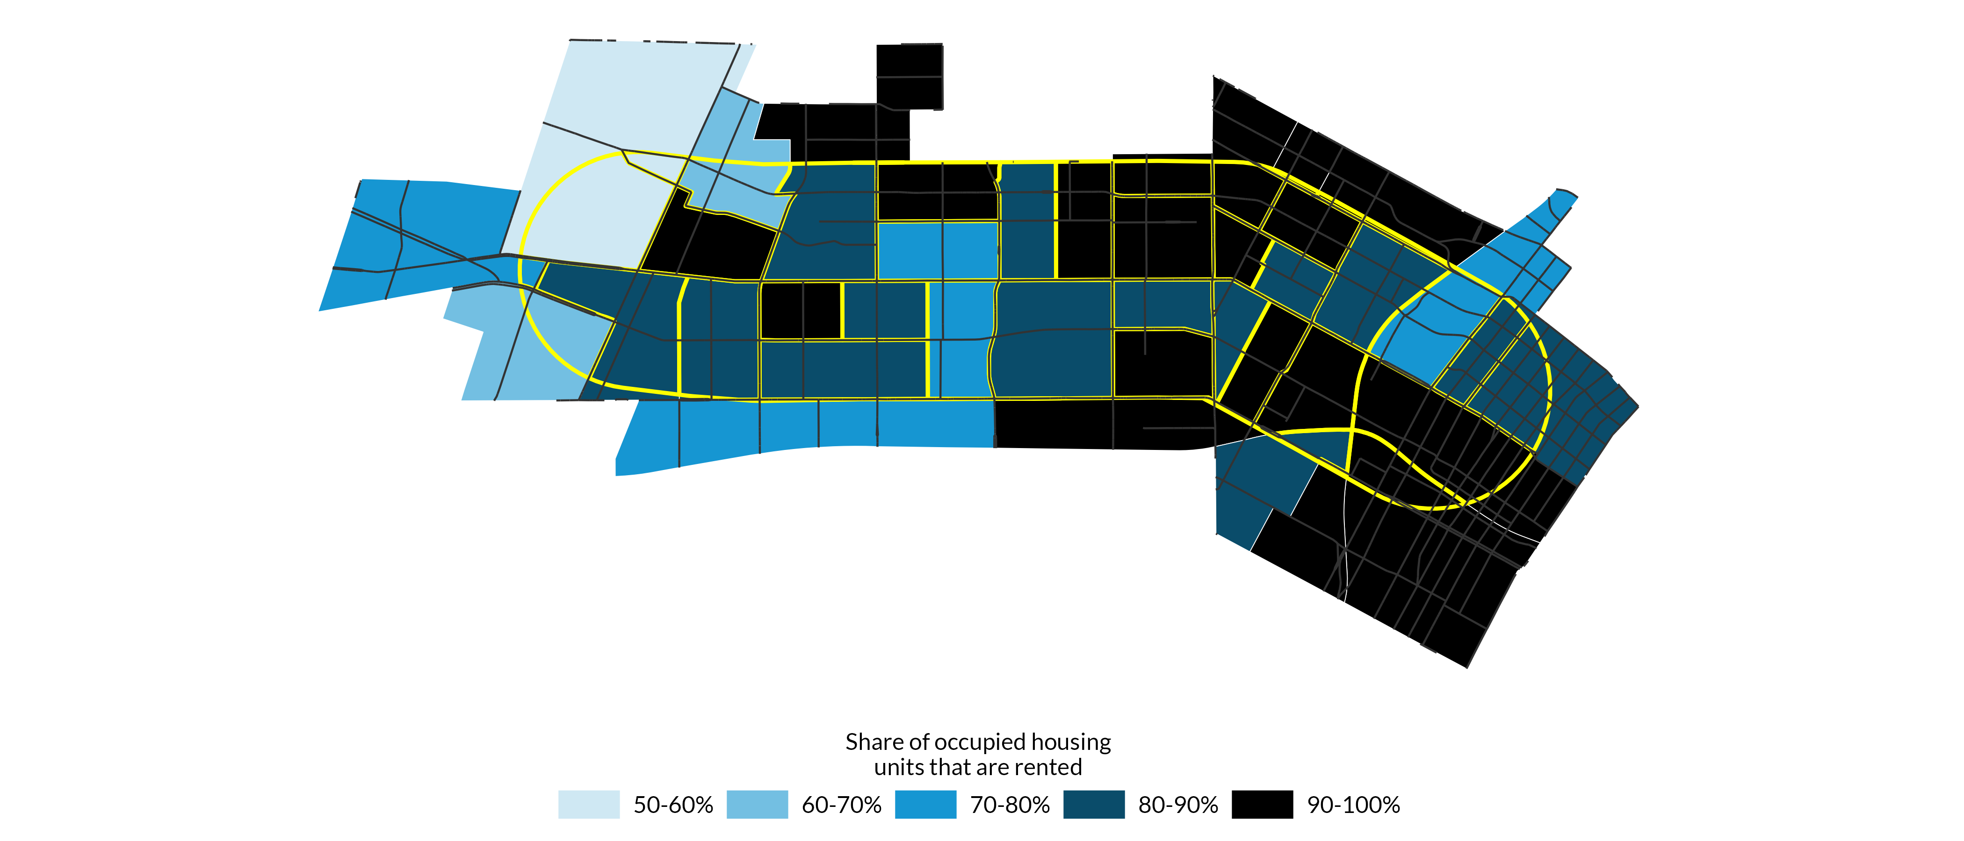**Source:** Authors’ analysis of 2019-2023 American Community Survey data table B25003, ’Tenure’.

**Notes:** Percentage is based off total number of units in each census tract.

A large proportion of renters in the Pico Boulevard corridor are cost burdened, typically defined as spending at least 30 percent of their income on housing. There are only six census tracts where the median share of income spent on housing is less than 30 percent, meaning that, on average, the median household in 40 census tracts is cost burdened (Figure 22). There are six tracts where the median household spends over 40 percent of the income on housing.

Moreover, there are 37 census tracts where over half of households are rent burdened, and 3 census tracts where over 70 percent of households are rent burdened (Figure 23). A high share of households across Pico tracts are severely rent burdened, defined as spending over half of income on housing costs (Figure 24).

FIGURE 22

Median Share of Income Spent on Housing

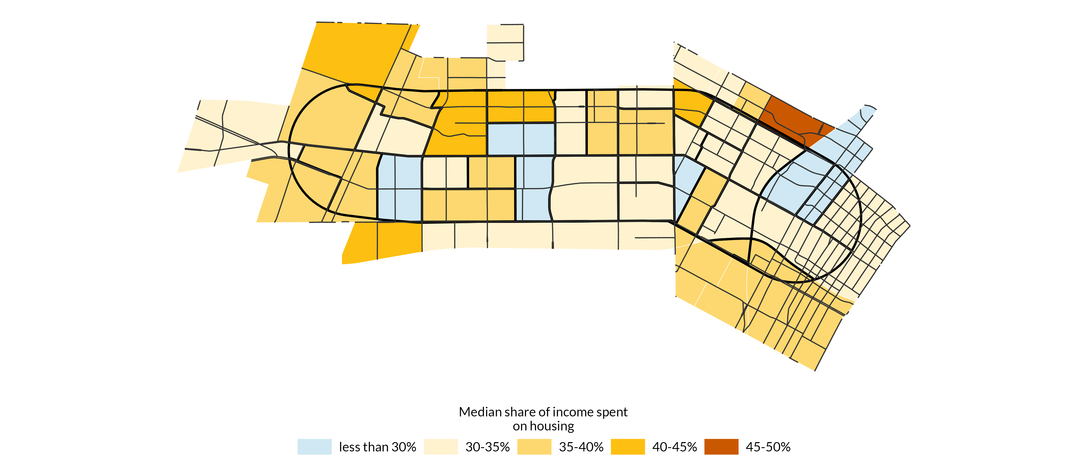**Source:** Authors’ analysis of 2019-2023 American Community Survey data table B25071_001, ’Median Gross Rent as a Percentage of Household Income in the Past 12 Months (Dollars)’.

FIGURE 23

Share of Households that are Rent Burdened

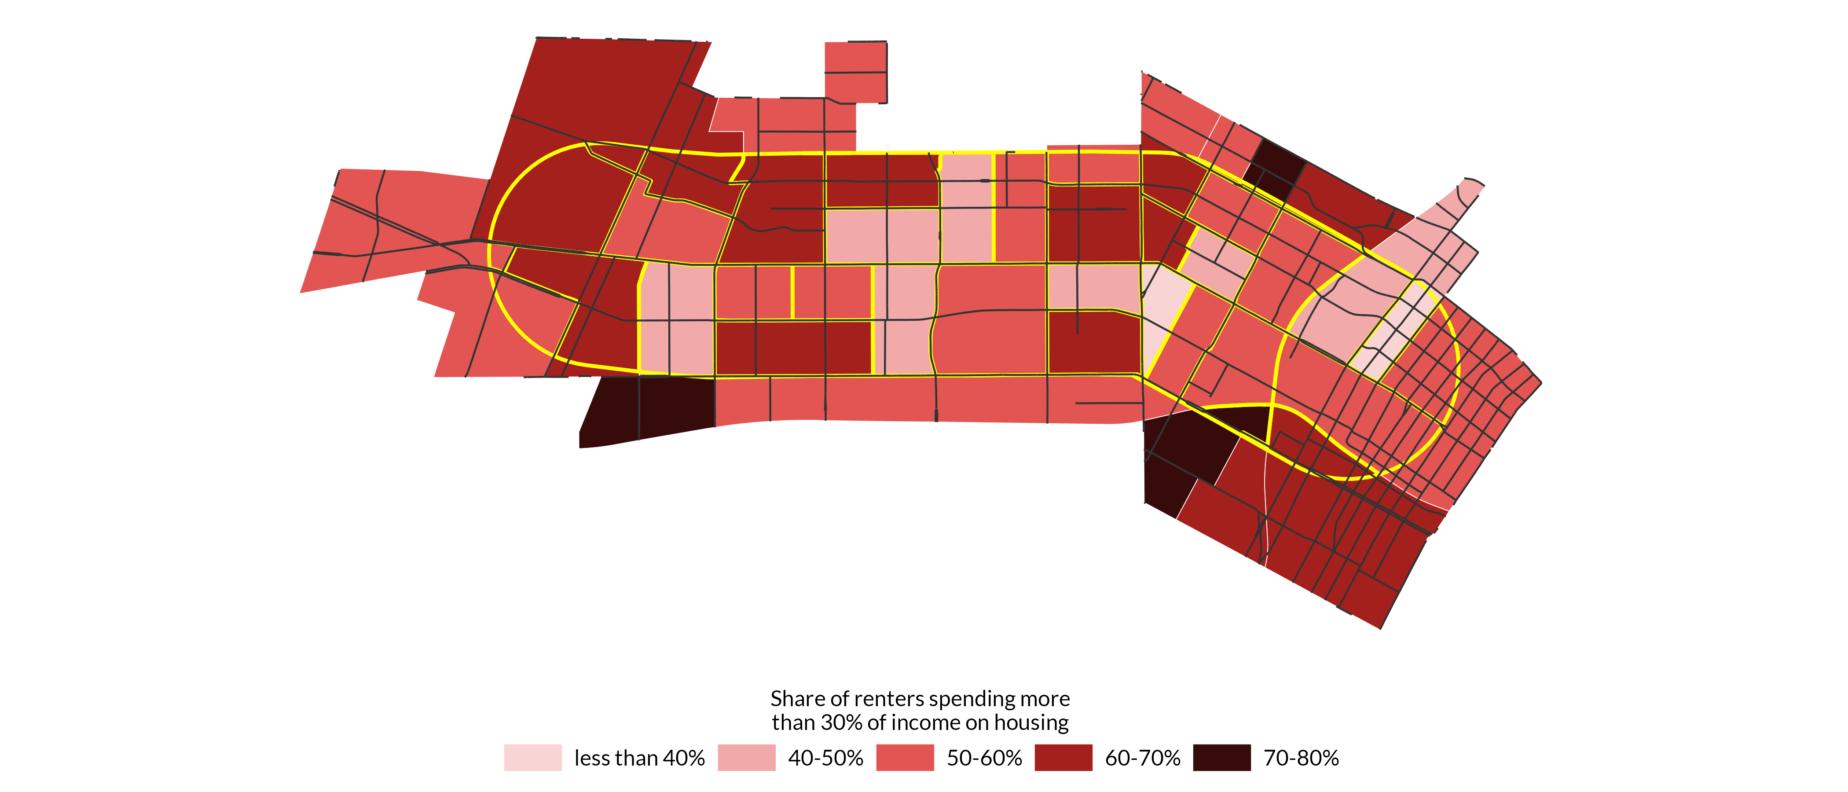

**Source:** Authors’ analysis of 2019-2023 American Community Survey data table B25070, ’Gross Rent as a Percentage of Household Income in the Past 12 Months’.

FIGURE 24

Share of Households that are Severely Rent Burdened

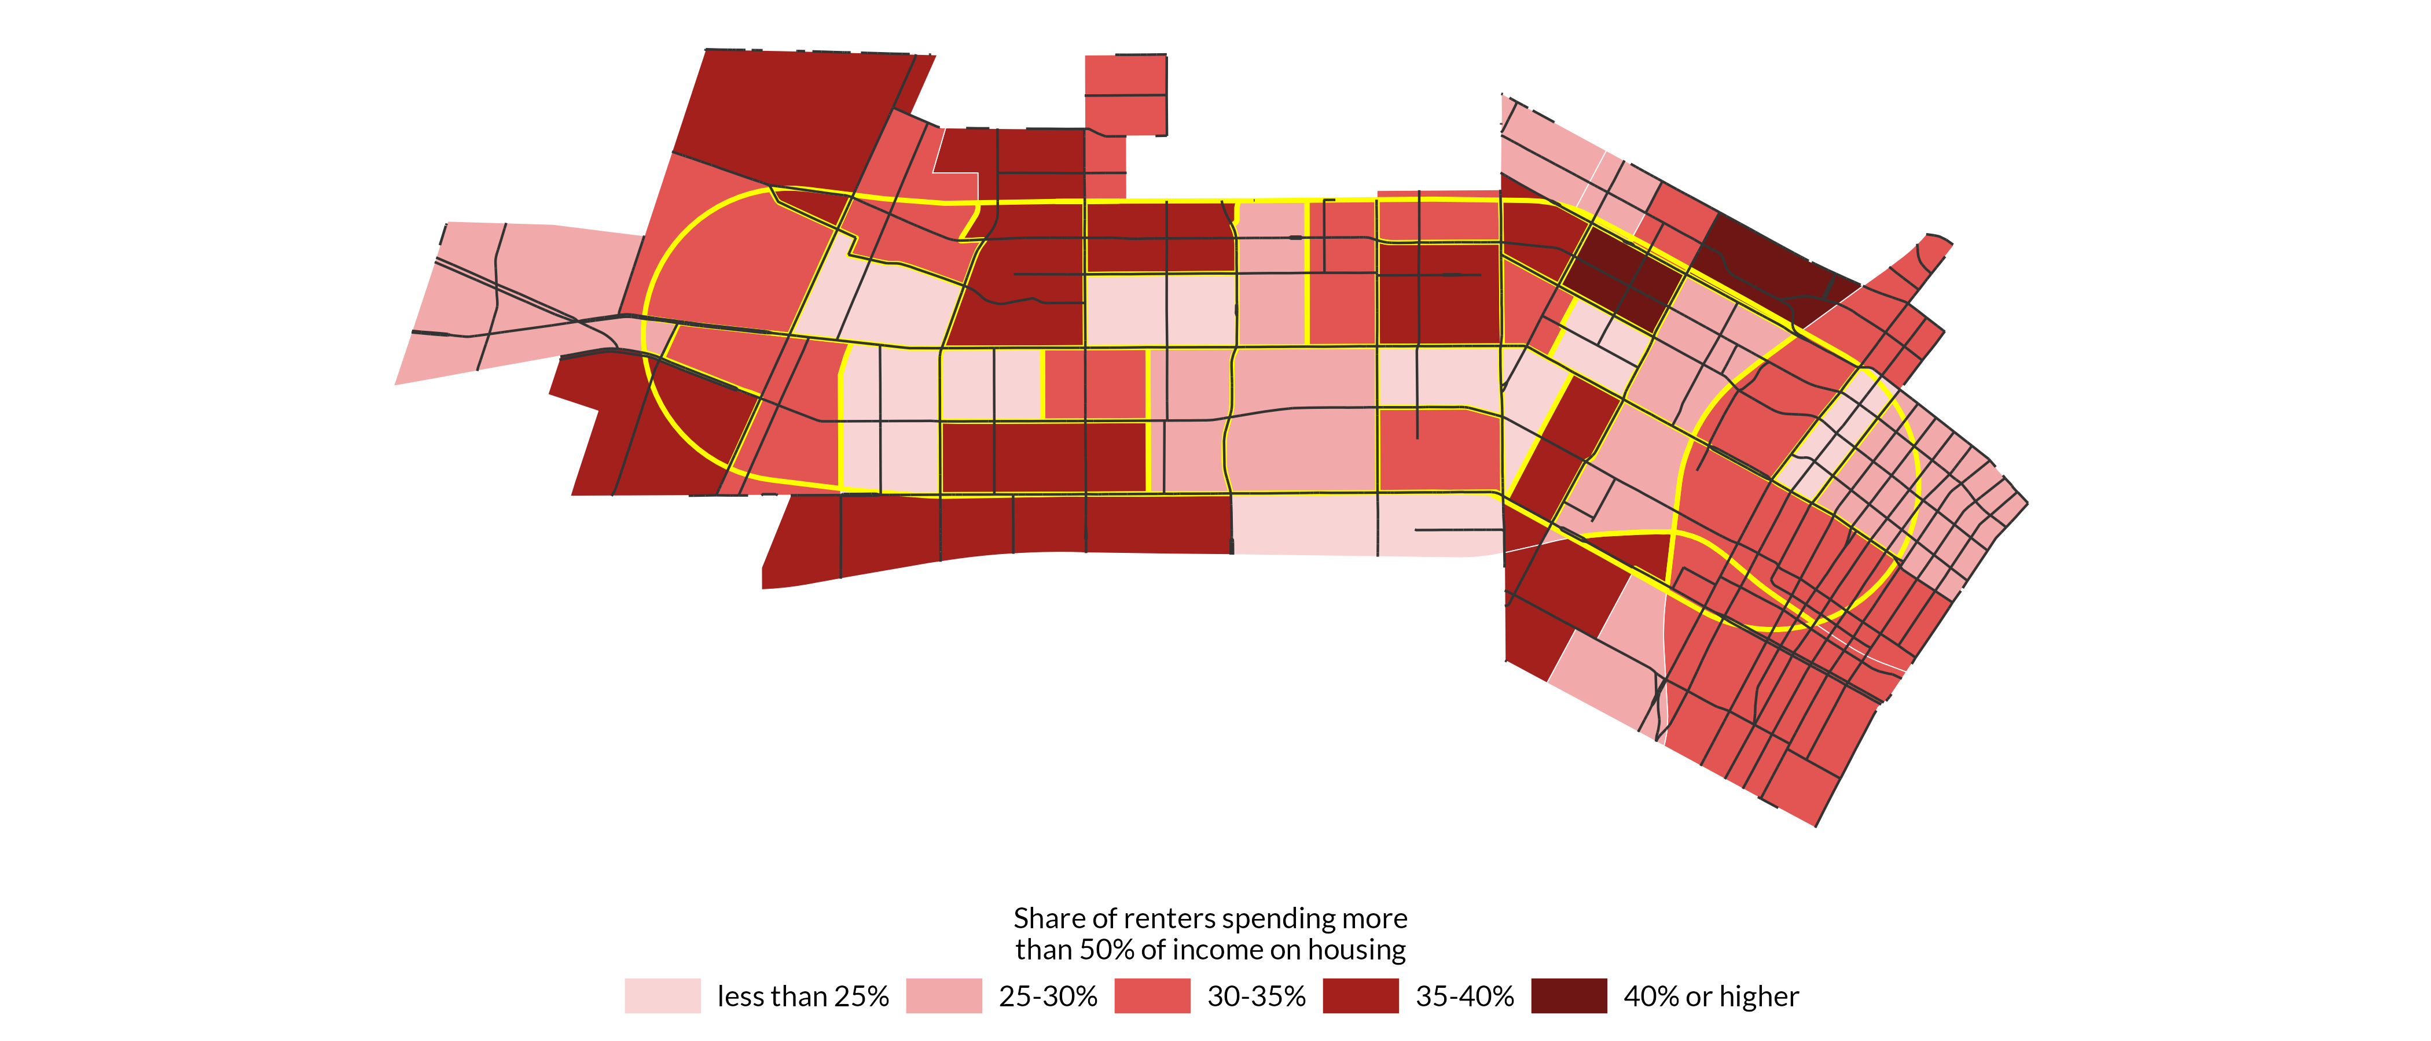**Source:** Authors’ analysis of 2019-2023 American Community Survey data table B25070, ’Gross Rent as a Percentage of Household Income in the Past 12 Months’.

**Notes:** Percentage is based off the total number of households in each census tract.

In 2012, California established a definition of “disadvantaged communities” (DACs) under Senate Bill 535. The purpose of this definition is to facilitate the targeting of strategic investments aiming to improve public health and economic opportunity to more burdened and resource-constrained communities. Generally, DACs are census tracts that suffer from high levels of pollution and environmental degradation and are the most economically distressed. In the Pico Boulevard corridor, 40 of 46 total census tracts meet this definition, highlighting the environmental and economic distress faced by the majority of community members.

## Transportation and commuting

Despite the car-centric urban form of Los Angeles, many households in the Pico Boulevard corridor lack car access. In the median census tract, about 24 percent of households do not have access to a car. However, there is large variation in car access, largely driven by spatial considerations. Many of the census tracts in the western area of the corridor have high car access, while many on the eastern side, particularly the southeast and the northeast, have lower levels of car access (Figure 24). One explanation for this may be proximity to transit. For instance, many of the census tracts with low levels of car access are located near light rail stations (Pico, Westlake/MacArthur Park, Wilshire/Vermont stations), while the more car-reliant tracts are located further. In the three tracts where the majority of households lack car access, light rail stations are the most accessible.

FIGURE 24

Share of Households Without Access to a Car

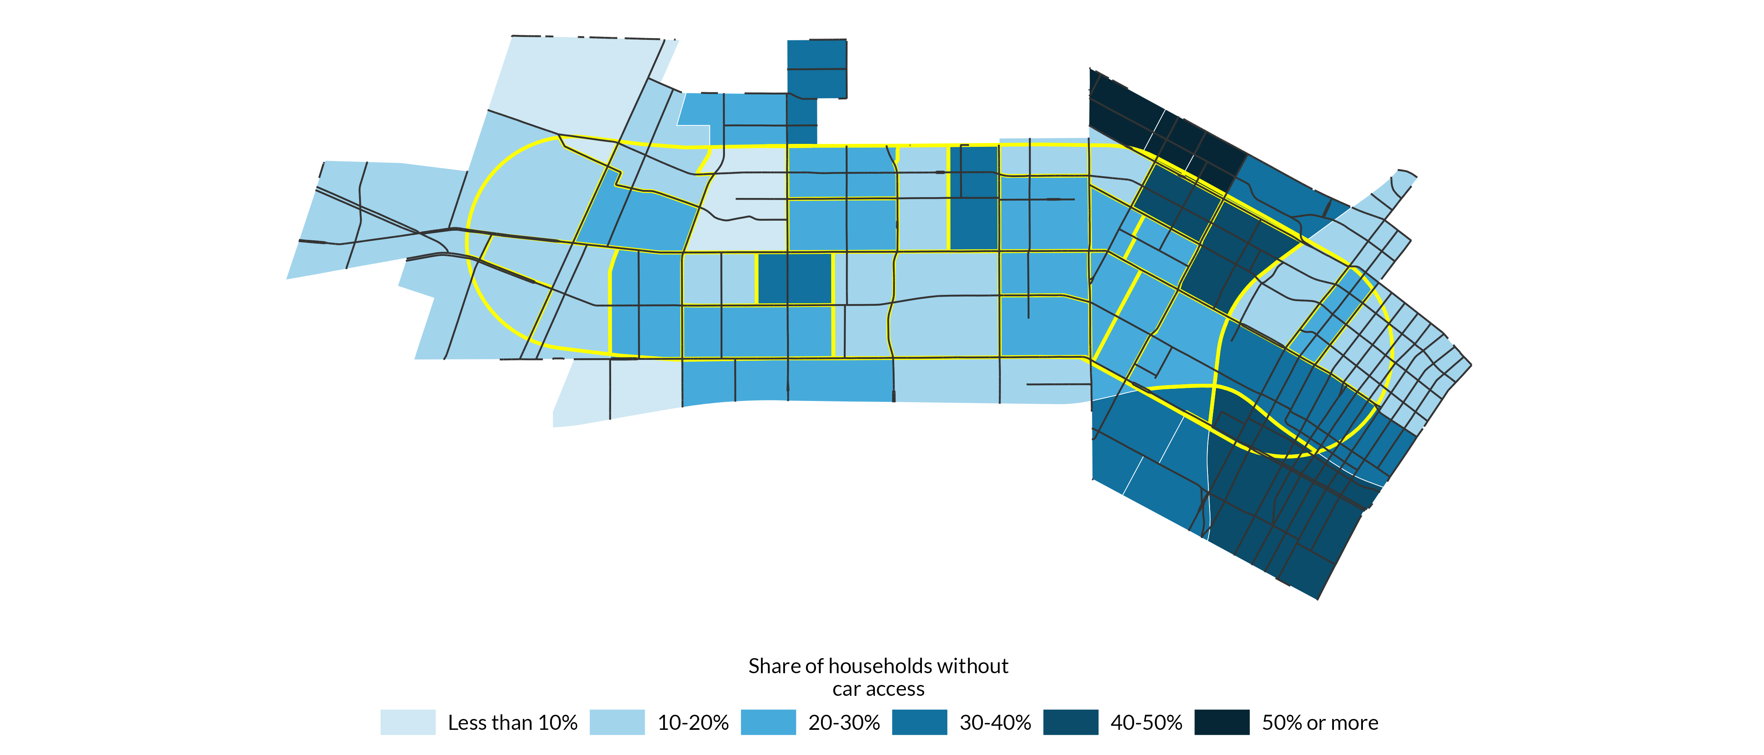**Source:** Authors’ analysis of 2019-2023 American Community Survey data table B25044, ’Tenure by Vehicles Available’.

**Notes:** Percentage is based off the total number of households in each census tract.

Along the same lines, most residents in the Pico Boulevard corridor commute via car (60 percent). About 18 percent of residents use public transit to commute and 13 percent work from home. Only 6 percent of residents walk or bike to work (Figure 25). About 67 percent of working residents have a commute time under 35 minutes, with most commutes ranging between 15 and 34 minutes (Figure 25). Approximately 14 percent of residents have a commute longer than one hour, and these residents are more likely to live in the northeast portion of the corridor (Figure 26). Notably, these tracts are closer to public transit and have lower levels of car access relative to the rest of the corridor.

FIGURE 25

Share of Pico Residents that Commute by Each Mode of Transit

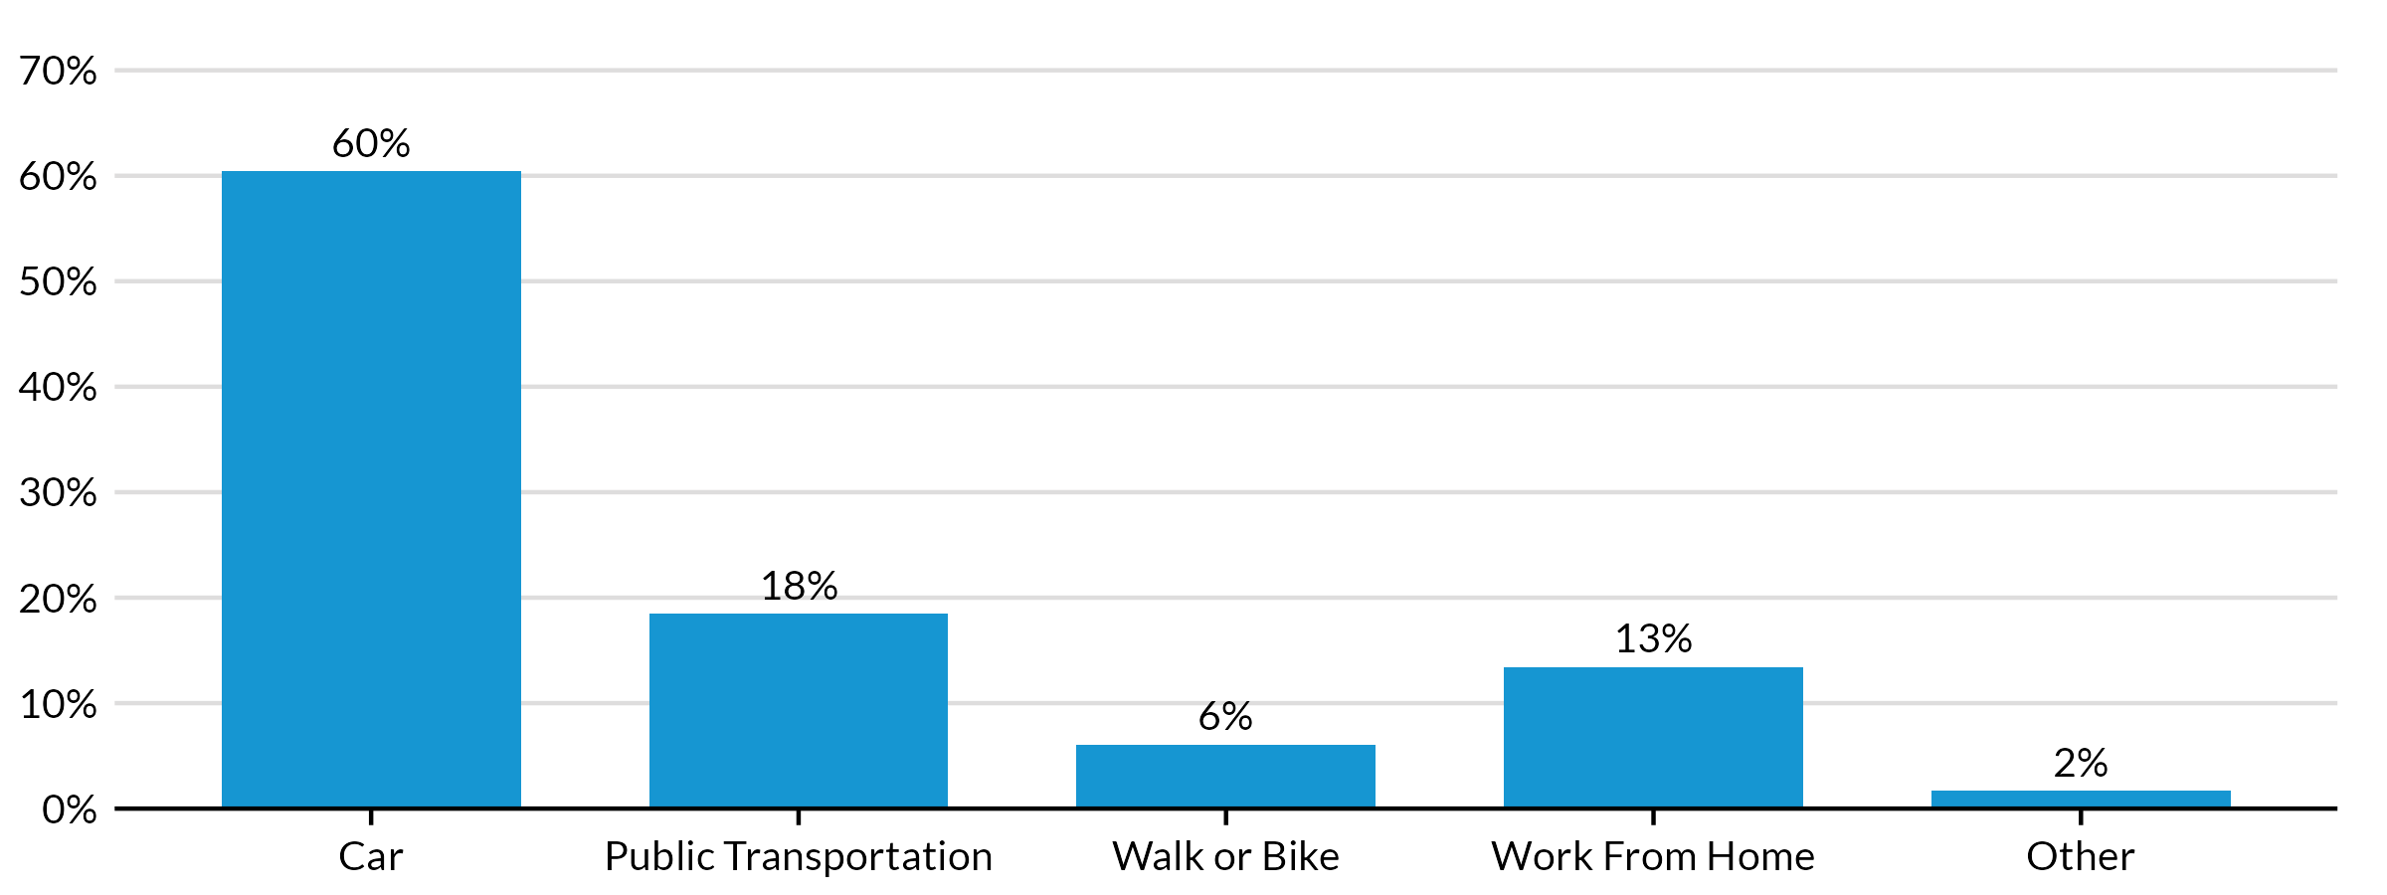**Source:** Authors’ analysis of 2019-2023 American Community Survey data table B08301, ’Means of Transportation to Work’.

**Notes:** Percentage is based on total population in the corridor.

FIGURE 26

Share of Pico Residents by Commute Time

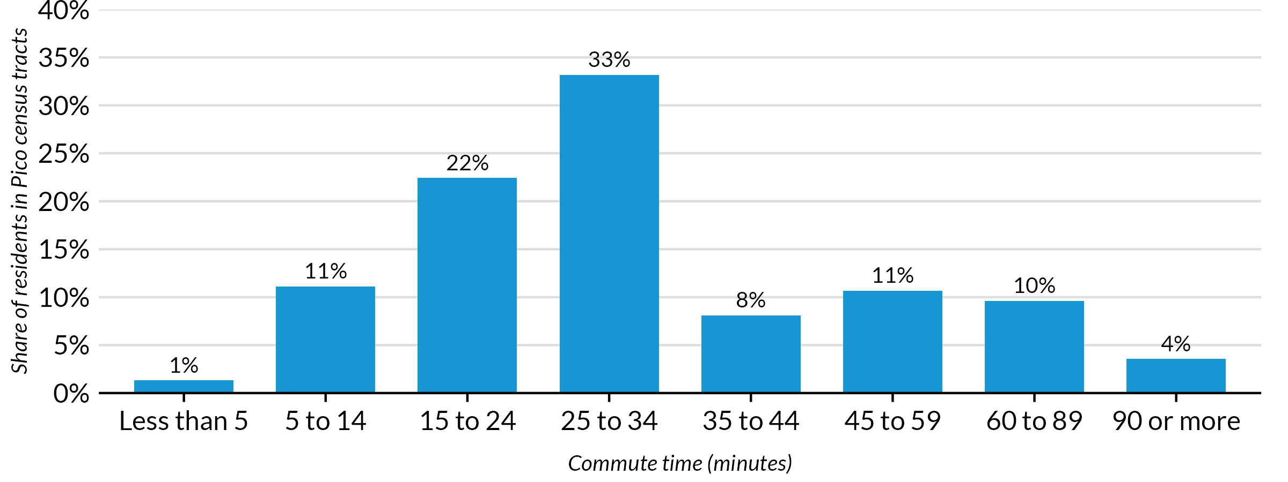**Source:** Authors’ analysis of 2019-2023 American Community Survey data table B08303, ’Travel Time to Work’.

**Notes:** Percentage is based on total population in the corridor.

FIGURE 27

Share of Residents with a 60+ Minute Commute

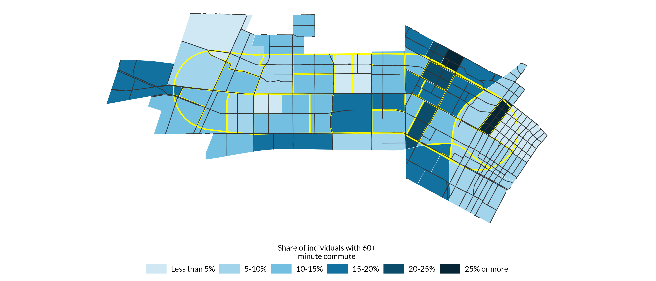**Source:** Authors’ analysis of 2019-2023 American Community Survey data table B08303, ’Travel Time to Work’.

**Notes:** Percentage is based off total population in each census tract.

There is substantial spatial variation with respect to the percentage of household income spent on combined housing and transportation costs. Using the [H and T Affordability Index](https://htaindex.cnt.org/map/) to analyze the percentage of income spent on housing and transportation costs, we observe that housing and transportation costs in the northeast and northwest areas of the corridor are the highest (Figure 28). H+T calculates this measure for a typical household making the area median income rather than calculating how much each house spends on housing and transportation. This means that the cost burdens shown in figure 28 below are the cost burden for a typical household in the Los Angeles region.

H and T also offers this measure for a household at the 80th percentile of area median income, which we show in figure 29. The pattern of cost burdens remains true when observing how much a household earning 80 percent of the area median income spends, with five census tracts in which a household spends over 60 percent of income on housing and transportation alone (Figure 29).

FIGURE 28

Share of Income Spent on H+T Costs, Adjusted by Area Median Income

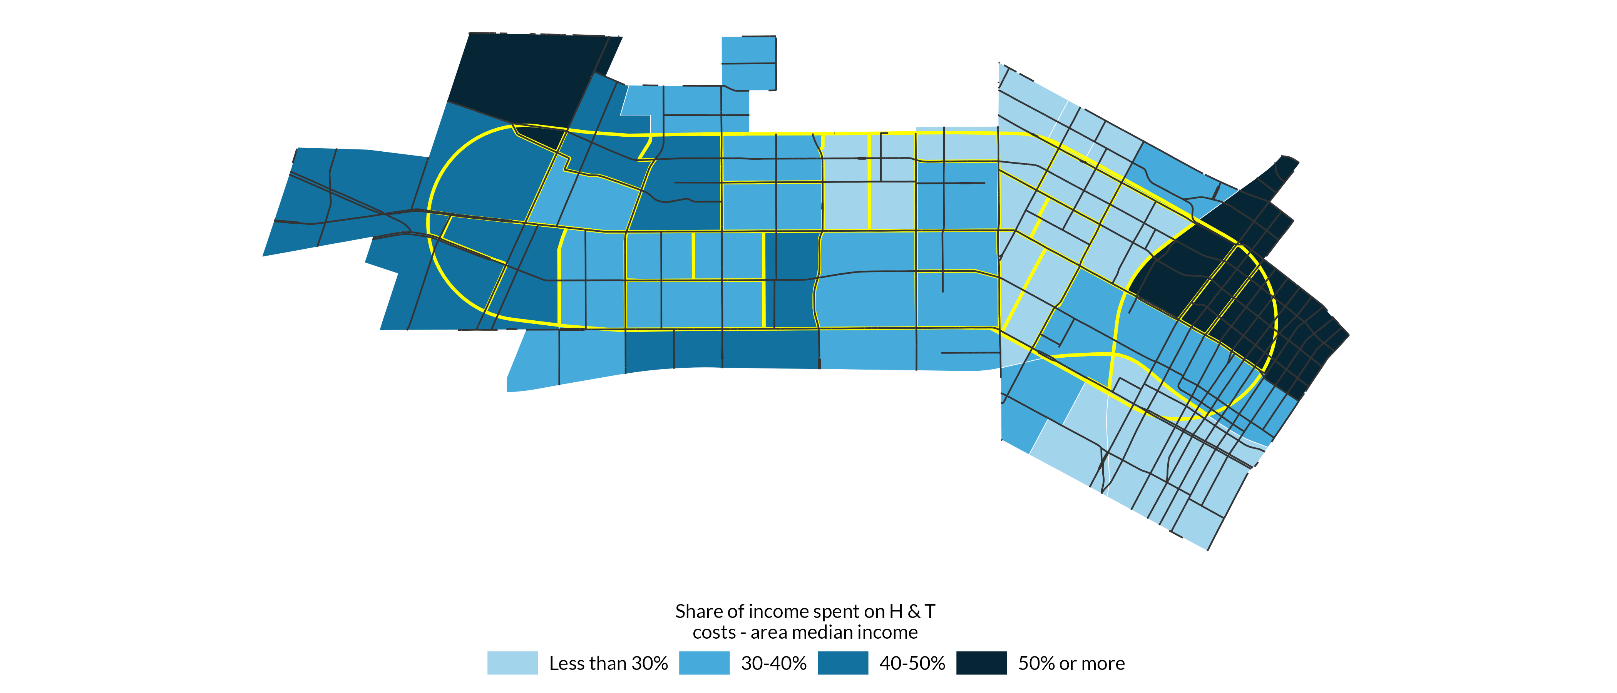**Source:** Authors’ analysis of H+T Affordability Index, developed by the Center for Neighborhood Technology, last accessed April 30, 2025, <https://htaindex.cnt.org/map/.>

**Notes:** Percentage is based off total population in each census tract.

FIGURE 29

Share of Income Spent on H+T Costs, Adjusted by 80th Percentile Area Median Income

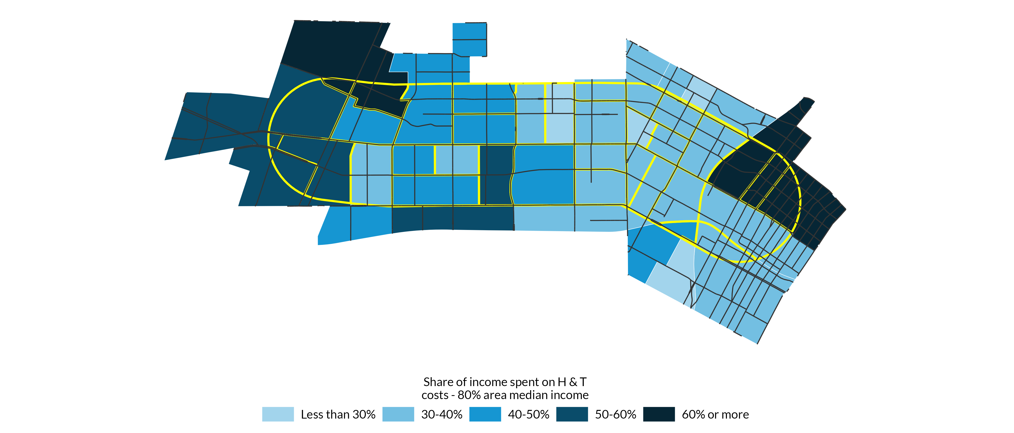**Source:** Authors’ analysis of H+T Affordability Index, developed by the Center for Neighborhood Technology, last accessed April 30, 2025, <https://htaindex.cnt.org/map/.>

**Notes:** Percentage is based off total population in each census tract.

According to the Transportation Injury Mapping System (TIMS), which assesses the California Statewide Integrated Traffic Records System (SWITRS), there were a total of 375 vehicle collisions along the Pico Boulevard Corridor from January 1, 2022 to December 31, 2022, which, according to TIMS, was the last full year of reliable data. As highlighted in figure 30, these crashes occurred across the corridor but are understandably concentrated in and around the intersection of Interstate 110, U.S 110, and Interstate 10, also known as the Dosan Anh Chang Ho Memorial Interchange. Given the higher quantity of motor vehicles on the interchange, this is to be expected.

However, there are other intersections throughout the corridor where crashes appear to be clustered, including on Vermont Avenue’s intersections with Pico Boulevard, Venice Boulevard, and Washington Boulevard. Given these findings are only based on one year of data from more than two years ago, they are not entirely current, but they still highlight the areas of the corridor where crashes could be more likely to occur, and where safety is important to emphasize.

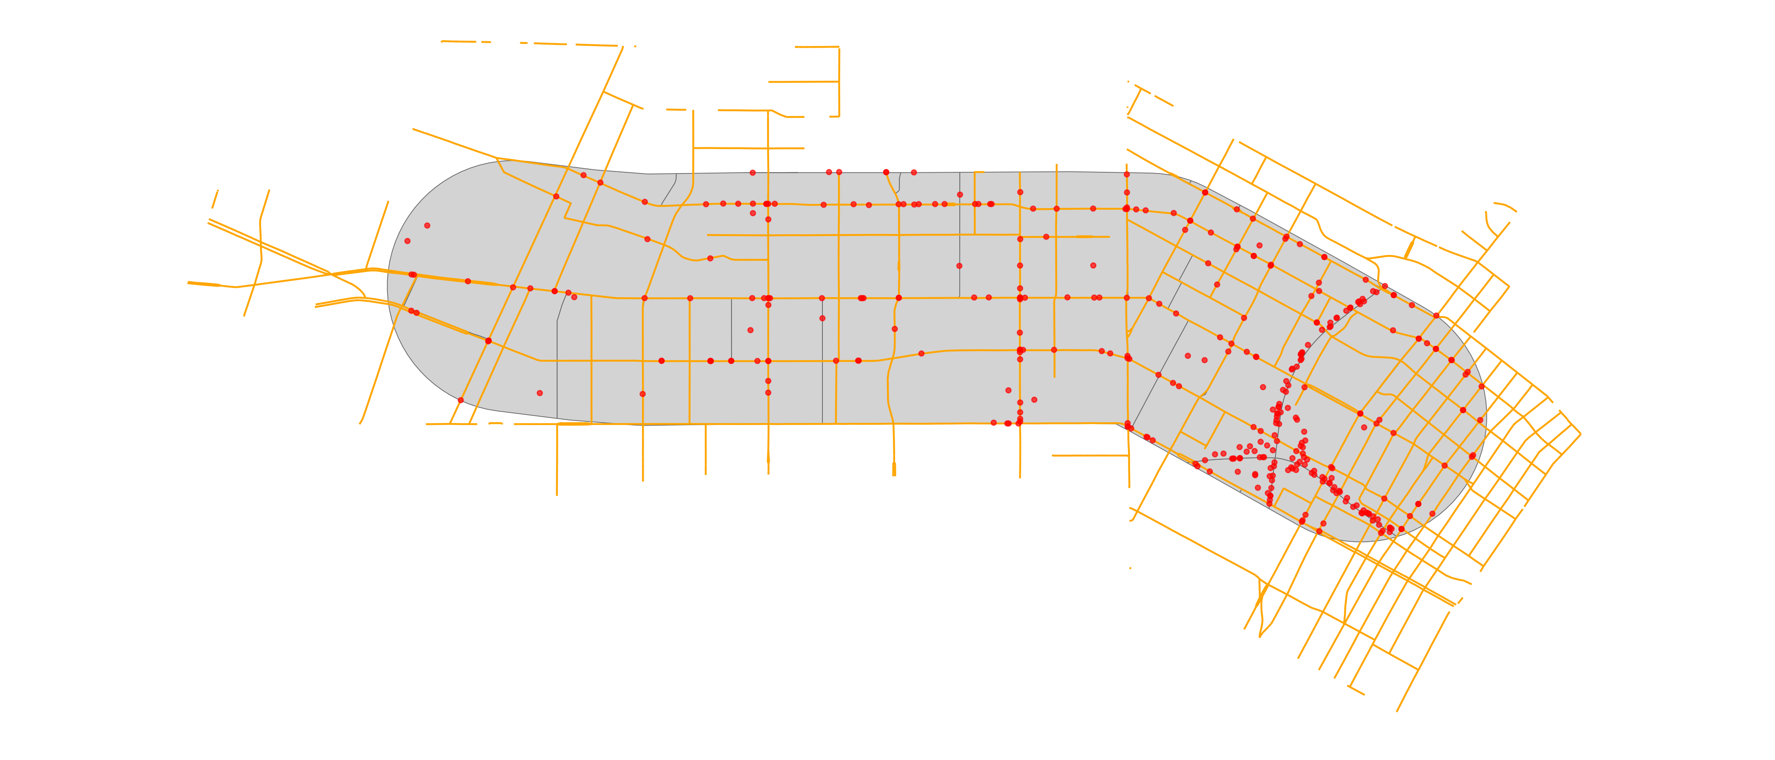FIGURE 30

Crashes along the Pico Boulevard Corridor from January 1, 2022 – December 31, 2022

**Source:** Authors’ analysis of Transportation Injury Mapping System (TIMS), last accessed April 30, 2025, <https://tims.berkeley.edu/tools/gismap/.>

**Note:** Crashes are from January 1, 2022 to December 31, 2022, as this is the last year with reliable data, according to the TIMS website. Includes fatal and non-fatal crashes.

## Land use

Finally, we examined the land use along the Pico Boulevard Corridor. According to the zoning application for the city of Los Angeles, the parcels directly on Pico Boulevard in the project area is almost entirely zoned for commercial use, while the stretch of Pico Boulevard from Alvardo Street to the 110 Overpass is zoned for commercial manufacturing purposes (figure 31).[1] However, the neighborhood within a half-mile of the corridor is primarily zoned for low-medium residential use, while the boulevards and avenues are lined with commercially-zoned properties much like Pico Boulevard. However, the western portion of the corridor, specifically west of Western Avenue, includes a number of lots of zoned for single-family commercial zoning. There is a smattering of lots zoned as public facilities throughout the corridor.

FIGURE 31

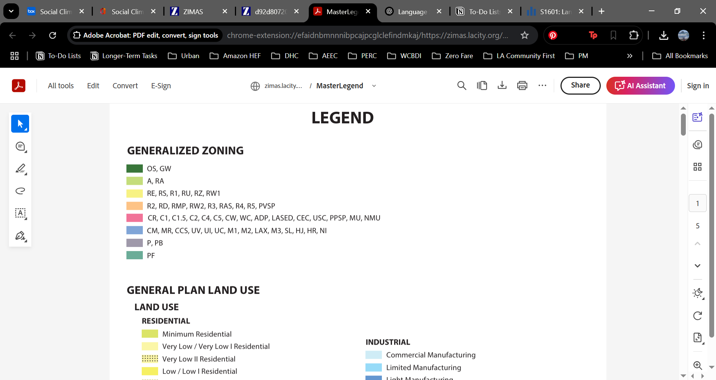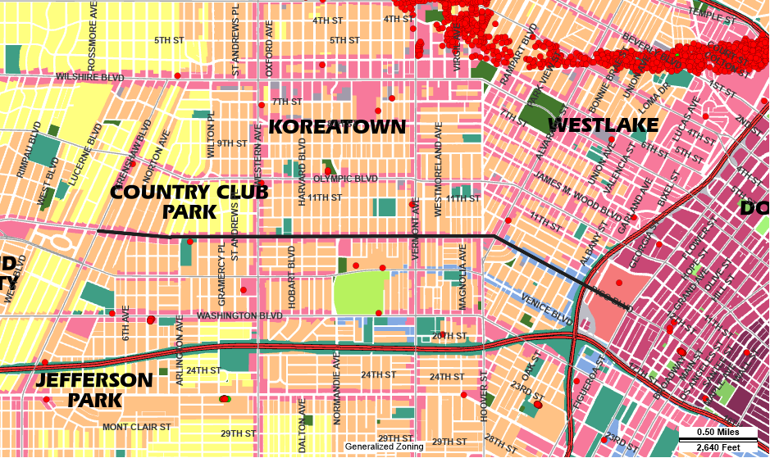Land Uses along Pico Boulevard

**Source:** Zone Information and Map Access System (ZIMAS), operated by the City of Los Angeles Department of Planning, last accessed April 29, 2025, <https://zimas.lacity.org/.>

**Notes:** The figure is a screenshot of the larger area around the Pico Boulevard Corridor and extends far past the corridor’s half-mile buffer from Pico Boulevard. The boulevard itself is loosely depicted by the black line extending horizontally through the map.

According to the Trust for Public Land, most of the Pico Boulevard Corridor is situated in a 10-minute walk service area, meaning it lies within 10 minutes from a park’s access points (figure 32).[2] However, there are several areas along the corridor that are outside of a 10-minut walk, and identified as “very high priority” areas for new parks. The Trust measures this priority based on six equally weighted factors: population density, density of low-income households, density of people of color, air pollution respiratory hazard, urban heat islands, and heath.

FIGURE 32

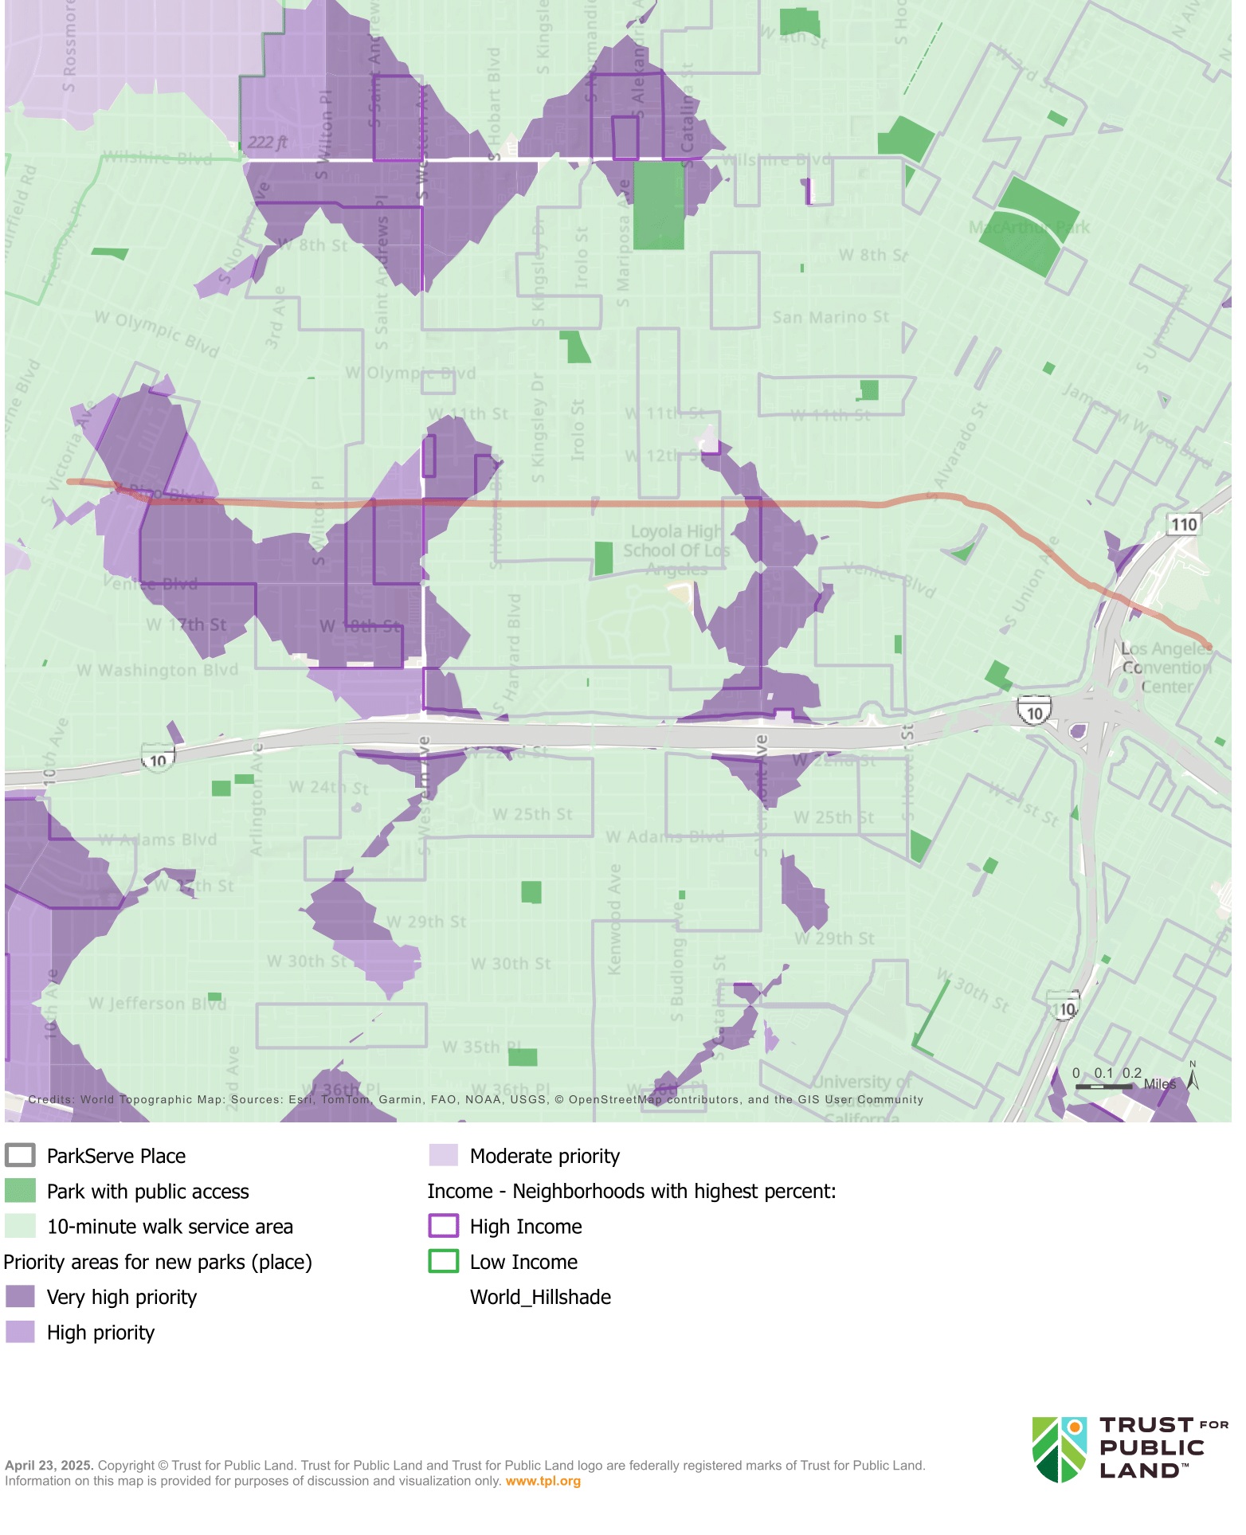Park Access Along Pico Boulevard

**Source:** Trust for Public Land ParkServe Index, last accessed April 29, 2025, <https://parkserve.tpl.org/mapping/#/?CityID=0644000.>

**Notes:** The figure is a screenshot of the larger area around the Pico Boulevard Corridor and extends far past the corridor’s half-mile buffer from Pico Boulevard. The boulevard itself is loosely depicted by the red line extending horizontally through the map.

Civic Engagement and Support for HLA

In March 2024, Los Angeles voters approved Measure HLA, a citizen-sponsored mandate intended to advance the city’s Mobility Plan 2035[3]. Figure 33 depicts the precinct-level voter data in the Pico corridor. While the majority of residents in every precinct in the corridor with available data appear to have voted in favor of the measure, some were more supportive than others.

FIGURE 33

Voter Support for HLA in the Pico Boulevard Corridor, by Precinct

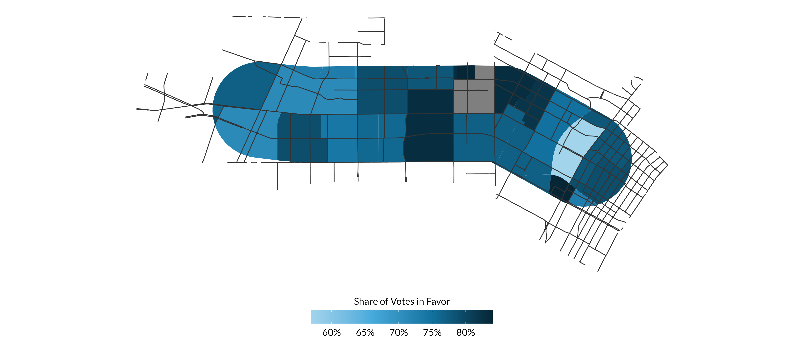**Source:** Precinct-level data of voter support for Measure HLA, a safe streets initiative passed in March 2024, <https://yesonhla.com/.>

**Notes:** Data for precinct 900517A is not available, and such is grayed out.

# Section Two: Field Observations

## Major Stakeholders and Outreach Considerations

* **Key Destinations:** Identify and list major locations relevant to the project, particularly those ideal for community outreach (e.g., schools, parks, commercial hubs).
* **Preferred Communication Channels:** Determine the most effective ways to engage with the community, such as:
  + Social media platforms
  + Email newsletters or listservs
  + In-person meetings or pop-up events
* **Trusted Messengers and Local Champions:** Identify respected community leaders or organizations who can help amplify outreach efforts and build trust.

## Existing Infrastructure and Use Patterns

The Pico Walk Audit was held on May 7th from 9:45am to 11:20am. The purpose of the walk audit was for the Community First Engagement project team to gain a deeper understanding of the street conditions and experience to inform the Pico engagement plan. The walk audit took place along a 1 mile stretch of Pico, from Bonnie Brae to Cataline St. The walk audit segment was further divided into three segments:

• Segment 1: Bonnie Brae St to Magnolia

• Segment 2: Magnolia Ave to Vermont Ave

• Segment 3: Vermont Ave to Catalina St

Thirteen people participated in the walk audit. While walking the segments of Pico Blvd, participants were asked to record their observations. The following text summarizes observations of each segment based on the participant’s feedback.

### Segment 1: Bonnie Brae St to Magnolia Ave

Segment 1 exhibited significant pedestrian safety and accessibility challenges, including frequent midblock crossings, faded or missing crosswalks, hazardous sidewalk conditions, and speeding vehicles. Participants also noted environmental concerns, limited parking, and heavy foot and vehicle traffic near schools, churches, and commercial areas.

Frequent Midblock Crossings and Speeding Hazards

Participants observed high levels of pedestrian activity and several safety and accessibility concerns. Several pedestrians and bicyclists were seen crossing Pico outside of crosswalks, particularly at the east side of Bonnie Brae where no crosswalk exists. Crosswalks at various intersections, including Magnolia, were either unmarked or faded, and some locations, such as near University Prep Value High School, had no crosswalks at all despite heavy foot traffic. Traffic was fast-moving throughout the corridor, with speeding cars observed at Bonnie Brae, Hoover, and Alvarado.

*"Older adults or people in wheelchairs can’t make it across in time — and then they’re still in the street when the light turns red."*

*"A veces los adultos mayores o personas en silla de ruedas no alcanzan a cruzar, y cuando llegan ya está en rojo.”*

*— Vendor*

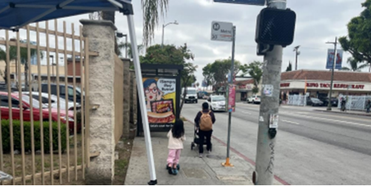Figure 1. Pedestrian walking along Pico Blvd.

Hazardous Sidewalks and Obstructions Impacting Accessibility

Sidewalk conditions varied but were frequently described as hazardous, with lifted, cracked, or uneven pavement reported between Westlake and Alvarado, and again near Arapahoe and Hoover.

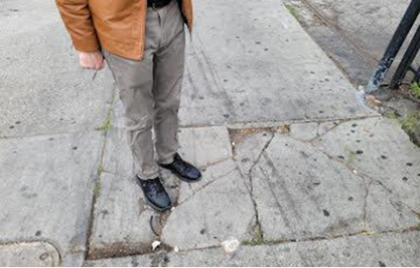Figure 2. Walk audit participant standing on cracked sidewalk.

Some sidewalks were obstructed by vendors, store displays, tables, and parked e-scooters, particularly near busy commercial spots like Ross Dress for Less and along intersections such as Westlake, Alvarado, and Hoover. Multiple locations lacked curb ramps or had missing ADA warning pads, and sidewalks were noted to be narrow or congested in several sections. Alleyways, especially those near the Salvation Army and between Arapahoe and Hoover, were flagged as areas of concern due to surface conditions and unclear pathways.

*"Sometimes [the scooters on sidewalks] come through too fast, 25 mph, and there are people walking out of stores... a kid could come out and have a bad accident."*

*"A veces pasan muy rápido, como a 25 millas por hora, y hay gente saliendo de las tiendas... un niño podría salir y tener un mal accidente."*

*— Bike shop worker*

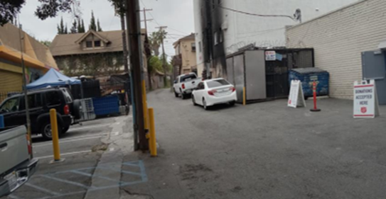Figure 3. Alleyway near Salvation Army.P

High Vehicle and Pedestrian Traffic and Environmental Concerns

Additional observations included high volumes of vehicle and pedestrian traffic around Ross and nearby churches, crowded bus stops, and active school drop-off and pick-up areas near 1929 Pico. Participants also noted environmental concerns such as street noise, visible trash, poor air quality, and a large curb radius at Westlake making pedestrian crossings feel exposed. Trees were reported as overgrown in some areas, with cracked sidewalks nearby and empty tree wells present. Parking was described as limited and difficult to find, with multiple comments pointing to competition for space near community destinations.

### Segment 2: Magnolia Ave to Vermont Ave

Segment 2 was marked by numerous pedestrian safety issues, including cracked and uneven sidewalks, obstructions from vendor setups and encampments, and a lack of ADA-compliant features. Participants also observed malfunctioning traffic signals, abandoned EV charging stations, and high vehicle speeds, leading to discomfort and unsafe conditions for pedestrians, despite some infrastructure improvements like bike parking and street cleaning efforts.

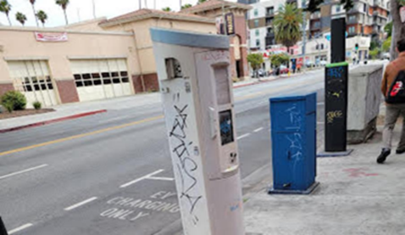Figure 4. Abandoned EV charging station.

Sidewalk Hazards and Obstructions Affect Pedestrian Movement

Throughout Segment 2, from Magnolia Avenue to Vermont Avenue, participants reported a wide range of physical and environmental conditions impacting pedestrian comfort and safety. Sidewalk hazards were common, with lifted and cracked pavement noted in multiple locations including between Westmoreland and Elden, at Menlo, Orchard, and from Vermont to Menlo. Several areas lacked ADA-compliant features, such as curb ramps—especially at the southeast corner of Westmoreland—and there were repeated mentions of narrow sidewalks not accommodating two-way pedestrian flow. Sidewalks were also blocked by bulky furniture, carts, large vendor setups, and personal belongings from encampments, notably near Menlo Avenue and the post office at Westmoreland. These obstructions, combined with high pedestrian volumes (including people carrying laundry, using wheelchairs, or pushing strollers), often forced individuals to walk close to or in the street. The laundromat, Pico 2 Coin Laundry, at Menlo was a frequent point of use, and many were observed pushing their laundry carts along Pico.

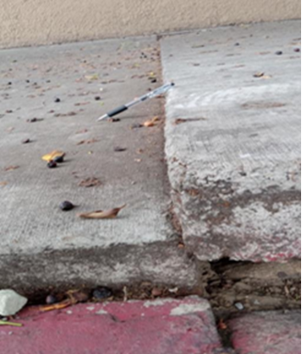

Figure 5. Lifted sidewalk with pen for scale, highlighting surface hazards.

Non-Functional Traffic Infrastructure and Dangerous Intersections

The corridor included a mix of active uses such as a busy laundromat, gas station, car wash, abandoned EV charging stations, and street vendors selling food and household items. A large encampment was noted near Menlo, and the area between Westmoreland and Pico had a heavy presence of scooters, carts, and dockless bikes, some abandoned on the sidewalks. Participants observed non-functioning pedestrian and traffic signals. These included including a red hand signal that was not working on the northbound east side at Westmoreland, a pedestrian signal was stuck on the walking man icon, and a non-operational speed feedback sign near Vermont. The intersection at Vermont and Pico was described as very busy, with fast-moving traffic in all directions. One person witnessed a car running a red light and making a left turn at Westmoreland. There were also road closures, such as Elden Avenue being blocked by planters, and alleyways were mentioned as sites for vehicle turning and U-turns, raising safety concerns. Observations indicated the presence of potholes, uneven streets, and overgrown tree roots, particularly around Magnolia and between Vermont and Menlo. The intersection of Pico and Westmoreland was flagged for poor curb ramp design and crosswalk placement, which contributed to pedestrian exposure and discomfort when crossing. Several noted that people crossing the street had very limited space, as vehicles passed very closely.

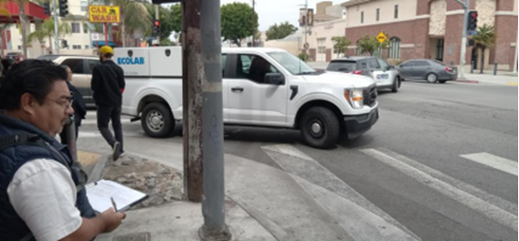Figure 6. Southeast corner of Pico and Westmoreland.

Moderate Comfort Levels Despite Infrastructure Improvements and City Services

Although some improvements like designated bike parking and EV stations were present, the environment was described as only moderately comfortable, with overall ratings ranging from 5/10 to 8/10. The mixed impressions were attributed to street cleaning efforts possibly tied to a Business Improvement District (BID) and a visible city infrastructure presence, such as Fire Station 13 near Westmoreland.

### Segment 3: Vermont Ave to Catalina St

In Segment 3, participants reported significant pedestrian discomfort due to cracked sidewalks, obstructions, and poor street conditions. Although public transit infrastructure was present, the area was described as moderately comfortable, with challenges like inadequate lighting, unsafe intersections, and fast-moving traffic compromising pedestrian safety and convenience.

Pedestrian Comfort Compromised by Sidewalk Damage and Obstructions

In Segment 3, from Vermont Avenue to Catalina Street, participants observed continued issues with pedestrian infrastructure and general street conditions. Sidewalks were frequently lifted, cracked, or broken, particularly between Vermont and New Hampshire, presenting hazards for pedestrians and wheelchair users. The sidewalks were also described as narrow and cluttered, with vendors, bulky items, and boxes from local businesses, such as a furniture store near Berendo, taking up walkway space. Many pedestrians were present in this segment, but the sidewalk width often did not accommodate the foot traffic comfortably.

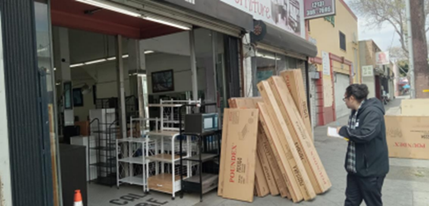Figure 7. Boxes reducing sidewalk space.

Street Conditions, Poor Lighting, and Unsafe Intersections

Several locations had potholes, uneven street surfaces, and cracked asphalt, especially near Catalina and between Vermont and New Hampshire. Street lighting was reported as poor, with one open electrical box noted and concerns about the area being very dark at night. Observers mentioned wire theft from utility infrastructure, and damaged or exposed electrical fixtures, including at a nearby fire station. Crosswalks were faded or in poor condition, particularly at the Vermont intersection, and one speed feedback sign near Vermont was not functioning. There were also complaints about not having enough time for pedestrians to cross at intersections like Catalina.

Public Transit Infrastructure and Overall Comfort

Traffic observations included fast-moving cars and instances of unsafe vehicle behavior, including drivers going straight through intersections from incorrect lanes at New Hampshire. Scooters and skateboards were seen riding on sidewalks, adding to congestion and safety concerns. Despite some areas feeling slightly wider—particularly between Catalina and Berendo—the overall pedestrian environment was limited by sidewalk quality, lighting issues, and vehicle behavior. Public transit infrastructure such as Metro’s 754 Rapid Line and several bus stops were present, though some were noted as needing general improvement. Participants described the segment as moderately comfortable but marked by several physical and environmental challenges. P

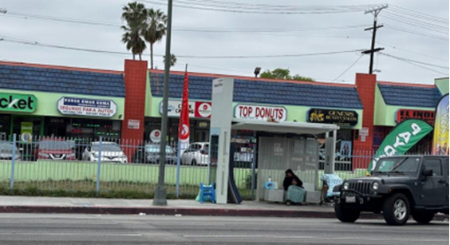Figure 8. Presence of public transit infrastructure.

### Summary

The Pico Walk Audit, conducted in three segments from Bonnie Brae Street to Catalina Street, revealed consistent issues affecting pedestrian and cyclist safety, accessibility, and comfort. Participants across all segments reported damaged or uneven sidewalks, faded or missing crosswalks, and frequent obstructions from vendors, bulky items, and encampments, making navigation difficult—especially for people using mobility devices. Bicyclists were often seen riding on sidewalks or against traffic due to a lack of dedicated bike infrastructure, and scooters and dockless bikes frequently blocked pedestrian paths. Speeding was a major concern throughout the corridor, with multiple reports of fast-moving vehicles and unsafe driver behavior at intersections. Poor lighting, non-functioning pedestrian signals, and exposed electrical fixtures added to the safety risks. While some amenities like bus stops, bike parking, and EV charging stations were present, the chargers appeared abandoned and underused. Overall, conditions were described as only moderately comfortable due to persistent issues with traffic behavior, sidewalk congestion, and inadequate space for both walking and biking.

## Observations from Project and Engagement Team

On May 7, 2025, the KDI and LADOT team walked along Pico Boulevard from 9:30 AM to 11:00 AM, covering the stretch between S. Hoover St. and Arapahoe St. The goal was to gather personal stories from residents—insights that are often missed through other engagement methods. The conversations focused on the main challenges residents face, their ideas for transforming the street to benefit everyone, and how they would like to be engaged throughout the project.

### Means of Transportation and Pedestrian Safety

Community members indicated that they regularly walk, bike, and use the bus. Many residents rely on public transit and walking as their primary mode of transportation. However, individuals frequently expressed concerns that unsafe alleyways, aggressive drivers, and areas lacking adequate lighting create dangerous conditions for pedestrians. Similarly, residents cited safety concerns resulting sidewalk conflict between on-foot pedestrians and fast-moving scooters and bikes. In addition, some individuals expressed that they felt a lack of personal safety when walking in sight of visible homelessness, and reports of graffiti, trash, and sidewalk obstructions affect the sense of comfort and dignity in public spaces.

Pedestrian burdens are often distributed unevenly across groups. For instance, older adults, women with children, and individuals with disabilities emphasized how brief pedestrian signal times create difficulties crossing the street and navigating the Pico Boulevard. Additionally, the incidence of general pedestrian safety issues such as inadequate lighting, a lack of crosswalks, and unsafe interactions with vehicles is greater for these groups.

### Informing Residents of Projects

Most residents indicated that they are unaware of projects unless they receive flyers or hear from others directly. They expressed a preference for outreach via flyers, posters, and local news as opposed to internet-based updates. They also noted the importance of communicating with images and other visuals to surmount language and literacy barriers. Specifically, local business owners suggested putting posters in stores and on posts to reach those “in their own world”.

*"I think the best thing [to engage and inform] is the way they are doing it now — talking to people. Flyers or posters? We take them and don’t read them."*

*"Creo que lo mejor es como lo están haciendo ahora — hablando con la gente. Volantes o carteles los tomamos pero no los leemos.”*

*— Scooter rider*

### Suggestions From Residents to Improve Pedestrian Safety

A recurring concern across interviews was that poor nighttime visibility leads to feelings of insecurity, and residents accordingly requested increased lighting. They also strongly supported protected bike lanes, as painted lines are not seen as sufficient for safety due to frequent vehicle incursions and disrespect for cyclists’ space. Several residents mentioned the need to repave streets, as frequent potholes and broken pavement are dangerous for cyclists. Community members also expressed a need to increase pedestrian safety on sidewalk. They emphasized that scooters and e-bikes use sidewalks aggressively and sometimes cause accidents, necessitating designated zones or greater enforcement. They also indicated a need for more clearly marked, visible pedestrian crossings, especially nears schools and intersections like Bonnie Brae & Pico. Some individuals a positive view of biking, particularly for mobility and health, and expressed interest in improving the cyclist experience to encourage mode shift.

## Storytelling and Participatory Planning

* **Storytelling:** Collect qualitative insights and anecdotal evidence from community members that highlight local experiences and needs.
* **Participatory Planning Activity:** Consider organizing a small-scale, interactive activity (e.g., mapping exercise, photo documentation) to gather visual or narrative feedback from the field visit.

# Section 3: Key Recommendations

This section presents recommendations informed by the findings in Sections 1 and 2 regarding the needs of community members in the project area to support their full participation in engagement efforts. By analyzing the intersections of age, race/ethnicity, income, disability status, housing insecurity, transportation needs, and existing behaviors, our team has identified priority populations and best practices for LADOT’s engagement initiatives. This data-driven approach is designed to help LADOT allocate resources strategically and concentrate efforts on communities that are poised to benefit most from the projects.

## Outreach strategy recommendations based on demographics

### Language Access

Since a large number of residents along the Pico corridor speak languages other than English, engagement efforts should be multilingual to ensure broad accessibility and inclusivity. Outreach materials should be provided in both English and Spanish at a minimum, recognizing that while many residents may speak some English, a significant portion are either not fluent or do not speak English at all. To maximize comprehension, English-language materials should be written in plain, straightforward language at approximately a 6th- to 8th-grade reading level.

In addition to Spanish, the presence of a substantial number of people of Korean descent—especially in the western portion of the corridor—suggests that including Korean-language materials as a standard component of outreach efforts will increase inclusion. Some attention should be given to Chinese and Tagalog-speaking populations as well, although these groups are smaller in size compared to the Spanish- and Korean-speaking communities.

Geographic differences within the corridor further suggest that outreach strategies should be tailored by location. In the eastern portion of the Pico corridor, where Spanish-speaking households are particularly concentrated, engagement should emphasize Spanish-language communication. In contrast, the western portion of the corridor, which features a higher proportion of households speaking Asian or Pacific Island languages, should prioritize Korean-language materials, with supplementary resources available in Chinese and Tagalog where appropriate.

Ideally, street teams conducting in-person outreach should reflect the linguistic diversity of the community. Bilingual Spanish-speaking and Korean-speaking staff would strengthen effectiveness, and additional capacity in Chinese and Tagalog will even further improve outreach efforts. These teams should also be equipped with localized information about language concentrations to better target their engagement efforts within specific tracts.

Partnerships with trusted community-based organizations, faith-based institutions, and local businesses will be critical for reaching immigrant and non-English-speaking communities. Collaborating with cultural centers and ethnic media outlets—such as Spanish-language newspapers, Korean radio stations, and community newsletters—will help disseminate information more broadly and credibly.

Furthermore, translation and interpretation services should be built into all public meetings, workshops, and events. Live Spanish and Korean interpretation should be offered, and Chinese and Tagalog interpreters should be available on-call as needed. All critical materials, including flyers, project updates, and surveys, should be translated into the relevant languages at each phase of engagement.

Finally, messaging should be culturally relevant, recognizing the distinct experiences and values of the corridor’s Mexican, Salvadoran, Guatemalan, Korean, Chinese, and Filipino communities. Communications should be crafted not just for language access, but also for cultural resonance, to build trust and encourage meaningful participation.

### Digital Access

To ensure equitable and inclusive community engagement along the Pico Boulevard corridor, outreach efforts must acknowledge and address the significant disparities in access to broadband and digital devices. Given that some census tracts in the eastern portion of the Pico Boulevard corridor have over 30% of households without internet access and over 10% without any device, community engagement strategies must not rely solely on digital tools such as websites, email, or social media. Recommended alternatives include:

* Printed flyers, mailers, and posters in multiple languages,
* In-person outreach via community canvassers, neighborhood meetings, or events,
* Telephone-based engagement, which can be accessed from landlines or cell phones.[4]

Digital strategies should also be adapted to reflect smartphone-only access. Engagement tools must be mobile-friendly, low-bandwidth, and accessible without requiring large file downloads or desktop interfaces. Text message surveys, mobile-optimized websites, and simple online forms can help ensure wider participation. Where feasible, public Wi-Fi access points, device loan programs, and digital literacy support should be offered to bridge access gaps.

### Disability Status

Residents with disabilities make up approximately 11 percent of the Pico area population. While this rate aligns with the countywide average, residents with disabilities are not uniformly distributed across the corridor. They tend to be concentrated in certain census tracts, particularly in the western, northeastern, and southeastern areas. In some of these tracts, more than 15 percent of the population has a disability, and there are nine tracts where over 500 individuals are affected.

Patterns of disability also vary by type. For example, while the median tract has 65 residents with a vision difficulty, some tracts in the eastern part of the corridor have over 150 individuals with a vision impairment. A similar trend exists for individuals with hearing difficulties: although most tracts have fewer than 3 percent of residents with hearing impairments, a small group of tracts contain more than 100 such individuals, with one tract having 256. Ambulatory difficulty is more evenly distributed but still shows higher concentrations in the same regions—western, northeastern, and southeastern Pico Boulevard.

In response to these patterns, community engagement efforts should be tailored to ensure accessibility for people with a wide range of disabilities and to focus outreach efforts in areas with higher concentrations of disabled residents. Specifically:

* All engagement materials and events should meet or exceed ADA accessibility standards, including offering large-print materials, Braille, ASL interpretation, captioning, and audio formats as appropriate. Visual materials should follow best practices for contrast and font readability, such as providing the right amount of space between lines of text, using clean typography, avoiding using all caps, not underlining text, and choosing a color scheme that provides high contrast between the text and the background[5].
* In-person engagement should occur at fully accessible locations and include mobility accommodations such as ramps, elevators, and accessible seating. Advanced notice should be given for accommodations, and transportation assistance may be needed for residents with limited mobility.
* Targeted outreach in the census tracts with the highest concentrations of residents with disabilities can help ensure these individuals are aware of and can participate in engagement opportunities. This could include working with disability service providers, independent living centers, and healthcare providers who serve these areas.
* Community engagement timelines should allow for additional flexibility, recognizing that scheduling transportation, caregivers, or communication support can require extra time for individuals with disabilities.
* Engagement design should be inclusive from the start, not as an afterthought. Engaging individuals with disabilities in the co-design and planning of outreach strategies can help identify and eliminate barriers before they arise.
* Collaborate with disability advocacy groups that represent people with disabilities (Brangman 2022).

### Age

The majority of residents within the Pico Boulevard project boundaries are between the ages of 30 and 44, the age cut points in the census that most closely align with the Millennial generation, with the other age categories having similar percentages of residents in them (including 0-17, 18-29, 45-59, and 60+). Based on this distribution, we recommend focusing on the following outreach strategies, **with a particular emphasis on those targeted at Millennials:**

To reach youth (0–18, includes Gen Z):

* Include activities for youth at events to engage both children and their parents.
* Use creative media: Engage youth through art, music, and digital media to foster connection  
  (Mirza et al., 2014).
* Gamify engagement: Incorporate game-like features and interactive tools to sustain attention (Lightbody, 2020).
* Leverage peer networks: Partner with youth organizations, schools, and colleges to engage young people through trusted social channels (Lightbody, 2020).
* Incentivize participation: Offer vouchers, event tickets, or discounts to motivate involvement (Lightbody, 2020).

To reach young adults (18–29, includes Gen Z):

* Embrace entertainment-based marketing: Use entertaining content tailored to current media trends and human-centered storytelling.[6]
* Prioritize the right platforms: Focus engagement on YouTube and Instagram, which are the most used platforms by this age group, but also conduct engagement on Facebook, Snapchat, and TikTok, since a large percent of people in this age group are also on those platforms.[7]

**To reach adults aged 30–44 (Millennials):**

* **Maintain a strong online presence: Create up-to-date profiles on major social networks and promote key information online.[8]**
* **Use real, relatable stories: Feature authentic stories from everyday people to foster empathy and connection.[9]**
* **Target major platforms: Focus on YouTube and Facebook, followed by Instagram.[10]**

To reach Gen X (ages 45–59):

* Focus on video and social platforms: YouTube is the primary platform used by this age group, followed by Facebook.[11]
* Use testimonials: Gen Xers like to know other people have already had positive experiences with engagement activities, and outreach materials that showcase everyday life and real-world situations will be most effective for this group.[12]

To reach Baby Boomers and older adults (60+):

* Recognize online presence: Many in this group use social media—63% use it to connect with loved ones, and they spend more time online than some younger cohorts.[13]
* Use trusted platforms: Focus on Facebook and Twitter; Instagram and Snapchat are less effective.[14]
* Combat skepticism: Ensure online messages are trustworthy and clear to overcome concerns about digital marketing.[15]
* Adapt communication methods: Use phone calls, in-person meetings, and printed materials to suit common preferences (Brangman, 2022).
* Use face-to-face outreach: Conduct personal outreach at familiar locations like senior centers or homes (Lightbody, 2020).
* Incorporate health-related content: Offer health incentives or resources to boost participation (Lightbody, 2020).
* Provide logistical support: Help with transportation or caregiving needs to make participation easier (Lightbody, 2020).
* Primary platforms: YouTube and Facebook are most widely used; 41% of those 65+ use Facebook.[16]

### Race/Ethnicity

The Pico Boulevard project boundaries include a significant population of people who are Hispanic/Latino and Asian. As such, the engagement team should take special care to conduct engagement in a way that acknowledges the historical context and attempts to build trust. Exploring and acknowledging prior municipal actions that harmed this community, such as Urban Renewal or transit projects that displaced people, is imperative for building a long-term engagement strategy that attempts to rebuild trust with the community.

In addition, since 48% percent of the population are immigrants, all outreach materials should protect the confidentiality of participants, and this confidentiality should be reminded to participants at each point in the engagement. For instance, survey materials should be conducted through secure platforms and information about a person’s race and ethnicity should never be stored alongside their name or other personally identifying information. This is particularly critical for immigrant communities that may fear legal repercussions or deportation (Brangman 2022).

Other tactics that the engagement team can take to increase the participation and comfort of immigrants in engagement activities include:

* Offering to walk participants to and from their cars
* Employing outreach workers or cultural brokers who share the same background as the target population to overcome cultural barriers and establish trust (Lightbody 2020).
* Holding community events in spaces where immigrant populations already gather, such as cultural centers, places of worship, or ethnic community groups (Lightbody 2020).

### Family structure

Since roughly 12,000 households along the Pico boulevard corridor include children under the age of 18, considering family needs during outreach and engagement activities is imperative. And, since almost half of these families with children are led by single parents, offering childcare at events is of utmost importance. Organizing family centric events can also be useful, since it allows parents and kids to connect with the engagement effort while also spending quality time together.[17]

### Other considerations

With each of these groups, community members in designing outreach strategies—and actively seeking their input and feedback throughout the process—can help ensure that engagement efforts are accessible and inclusive of all residents.

Additionally, building long term trust with communities, particularly those harmed by past policies or practices, requires entering early to listen to residents’ needs before proposing solutions. Too often, engagement occurs only after key decisions have been made, resulting in solutions that may not reflect community priorities or, worse, may cause unintended harm. Listening early on to the needs of residents and including them in decision making is key to increasing equity (Stacy et al. 2022). Equally important is closing the loop: after decisions are made, it is critical to report back to community members and explain how their input influenced the outcome.

The engagement team should also continuously monitor key metrics throughout the process and adjust strategies accordingly. For example, in a community where 57 percent of residents identify as Hispanic or Latino and 21 percent of residents identify as Asian, as is the case in the Pico Corridor, outreach efforts should aim to ensure that approximately 57 and 21 percent of participants, respectively in engagement activities and survey responses reflect those demographics. If engagement disproportionately involves non-Latino residents, the team should revise its strategies to better reach underrepresented groups using the tools described above. Residents engaged in outreach efforts should similarly reflect the share of renters (87%) and homeowners (13%) and the share of residents living below the federal poverty line (24%).

Additional best practices for equitable community engagement—adapted from Stacy et al. (2023)—are outlined in the accompanying box.

Box 1

Best Practices for Equitable Community Engagement

To foster equitable and effective community engagement, cities should invest in deep engagement early in the process and continue throughout implementation. Key strategies include:

* **Center historically excluded voices:** Prioritize engagement with people with low incomes, people of color, and others historically left out of decision making by hosting events in familiar community spaces or partnering with trusted grassroots organizations. Hire local residents for outreach.
* **Offer multiple participation options:** Provide both in-person and virtual engagement opportunities, including small-group discussions tailored to specific language or cultural needs, to ensure accessibility and comfort for all participants.
* **Compensate and support participants:** When feasible, pay community members—especially those in leadership roles—for their time. Offer supports such as childcare, transportation vouchers, and food to remove participation barriers.
* **Maintain transparency and follow up:** Share decisions, next steps, and how community input was used to build trust and demonstrate accountability.
* **Track progress on inclusion:** Monitor engagement demographics in real time and solicit feedback through focus groups to identify gaps and opportunities for improvement.

Source: Adapted from Stacy, Christina Plerhoples, Leah Hendey, Steven Brown, and Kathryn L.S. Pettit. *Disrupting Structural Racism: A Research Agenda for Advancing Equitable Housing Outcomes.* Washington, DC: Urban Institute, 2023. <https://www.urban.org/research/publication/disrupting-structural-racism>

## Recommended Project Partners & Ambassadors

* The following Resident Leaders, Neighborhood Councils, and Community Based Organizations will be directly engaged through this project:
* Provide the list of resident leaders, neighborhood councils and community-based organizations whose commitment/partnership you will seek. List any potential community leaders who should be identified as community ambassadors for this project.

## Business Engagement Recommendations

* The following Businesses will be directly engaged through this project:
  + List businesses
* Provide a list/or overview of the business whose commitment/partnership you will seek.

## Scope and Timeline Considerations (if applicable)

* Provide an overview of any scope and timeline considerations that should be made given the findings and analyses indicated in this report.

# Appendix A. Public Comments

* [ATTACH ALL PUBLIC COMMENTS COLLECTED DURING THIS SOCIAL CLIMATE ANALYSIS.]

# References

Brangman, S. A. (2022). Achieving diversity in study populations: The importance of community engagement. National Institutes of Health, 1(1), 1-10. <https://pmc.ncbi.nlm.nih.gov/articles/PMC9669248/pdf/nihms-1835212.pdf>

Einstein, Katherine Levine, David M. Glick, Maxwell Palmer. Neighborhood Defenders: Participatory Politics and America’s Housing Crisis. Cambridge University Press; 2019.

Eskew, R., Dumez, C., & Ripple, B. (2014). Community engagement toolkit: Engaging people in planning and design. Wyandotte County Health Department. Retrieved from <https://www.wycohealth.com/wp-content/uploads/2014/05/EDR-Toolkit-Present.pdf>

Lightbody, R. (2020). ‘Hard to reach’ or ‘easy to ignore’? Promoting equality in community engagement. Glasgow Caledonian University. Retrieved from <https://researchonline.gcu.ac.uk/files/27037627/WWSHardToReachOrEasyToIgnoreEvidenceReview.pdf>

Mirza, Raïsa, Vodden, Kelly, & Collins, Gail. (2014). Developing innovative approaches for community engagement. Memorial University of Newfoundland. Retrieved from <https://d1wqtxts1xzle7.cloudfront.net/35845021/community_engagement-libre.pdf>

Stacy, Christina, Karolina Ramos, Donovan Harvey, Sonia Torres Rodríguez, Jorge Morales-Burnett, and Sabina Morris. 2022. “Disrupting Structural Racism Increasing Transportation Equity in South Dallas.” Urban Institute. <https://www.urban.org/sites/default/files/202212/Disrupting%20Structural%20Racism.pdf>

# Notes

1. <https://zimas.lacity.org/>
2. <https://www.tpl.org/parkserve>
3. Asia Mieleszko, ”The People of Los Angeles Just Said ’Yes’ to Safer Streets,” Strong Towns, March 12, 2024, <https://www.strongtowns.org/journal/2024/3/12/the-people-of-los-angeles-just-said-yes-to-safer-streets.>
4. ”5 Methods for Non-Internet Based Remote Community Engagement.” Medium. Accessed on April 25, 2025. https://medium.com/the-guide-to-remote-community-engagement/5-methods-for-non-internet-based-remote-community-engagement-689fc152de78
5. ”Color Contrast.” Colorado State University. Accessed April 20, 2025. <https://www.chhs.colostate.edu/accessibility/best-practices-how-tos/color-contrast/>; ”Design for Readability.” Harvard University. Accessed April 20, 2025. https://accessibility.huit.harvard.edu/design-readability
6. Kitheka, Joy. 2024. ”Marketing to Different Age Demographics.” BeeLiked. <https://www.beeliked.com/blog/audience-engagement/marketing-to-different-age-demographics>
7. “Social Media Fact Sheet.” Pew Research Center. Accessed April 25, 2025. https://www.pewresearch.org/internet/fact-sheet/social-media/#who-uses-social-media
8. Kitheka, Joy. 2024. ”Marketing to Different Age Demographics.” BeeLiked. <https://www.beeliked.com/blog/audience-engagement/marketing-to-different-age-demographics>
9. Kitheka, Joy. 2024. ”Marketing to Different Age Demographics.” BeeLiked. <https://www.beeliked.com/blog/audience-engagement/marketing-to-different-age-demographics>
10. “Social Media Fact Sheet.” Pew Research Center. Accessed April 25, 2025. https://www.pewresearch.org/internet/fact-sheet/social-media/#who-uses-social-media
11. “Social Media Fact Sheet.” Pew Research Center. Accessed April 25, 2025. https://www.pewresearch.org/internet/fact-sheet/social-media/#who-uses-social-media
12. “Marketing to Gen X: Reaching the Lost Generation.” Spotify. Accessed April 25, 2025. https://ads.spotify.com/en-US/news-and-insights/marketing-to-gen-x/
13. Kitheka, Joy. 2024. ”Marketing to Different Age Demographics.” BeeLiked. <https://www.beeliked.com/blog/audience-engagement/marketing-to-different-age-demographics>
14. Kitheka, Joy. 2024. ”Marketing to Different Age Demographics.” BeeLiked. <https://www.beeliked.com/blog/audience-engagement/marketing-to-different-age-demographics>
15. Kitheka, Joy. 2024. ”Marketing to Different Age Demographics.” BeeLiked. <https://www.beeliked.com/blog/audience-engagement/marketing-to-different-age-demographics>
16. “Social Media Fact Sheet.” Pew Research Center. Accessed April 25, 2025. https://www.pewresearch.org/internet/fact-sheet/social-media/#who-uses-social-media
17. ”How to Make Connections That Matter: Your Nonprofit’s Guide to Community Engagement.” DonorDock. Accessed April 25, 2025. https://www.donordock.com/articles/community-engagement-guide#4h25e